PREDICTION:

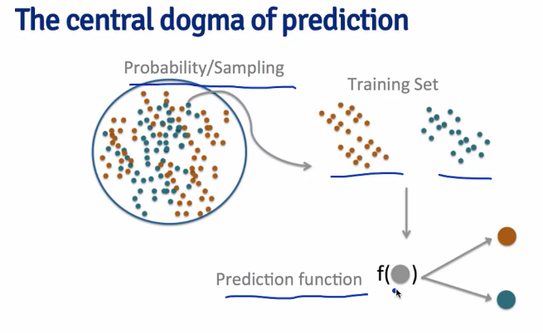

Suppose we have a dataset of red and blue balls. Now we take a sample of these red and blue balls each and train the sample and create a prediction function. Now, what this prediction function does is that it classifies a random ball whose color is not known into whether it is red or blue .

Now, we create a very basic prediction model , we want to predict spam or non – spam emails on the basis of frequency of the word ‘your’ in an email:

If frequency is > 0.5 , email is a spam and not otherwise.

prediction<-ifelse(spam$your>0.5,"spam","nonspam")

Now , we compare our prediction model to the actual prediction made in the data set:

xtabs(~prediction+spam$type)

spam$type

prediction nonspam spam

nonspam 2112 468

spam 676 1345

We see that out of our total predicted non spam emails i.e. 2580 , 2112 are in actual non-spam and 468 are spam. Similarly for spam emails , out of the total 2021 emails , 676 are in actual non-spam and 1345 are spam.

Hence our prediction is correct 2112/2580 i.e. 81.8% correct for non spam email and 1345/2021 i.e. 66.5% correct for spam emails.

INSAMPLE AND OUTSAMPLE ERRORS:

1.In sample error is in the same data which we have used to train our predictor , also called resubstitution error.

In Sample error is always going to be a little bit optimistic , from what the error is that you would get from a new sample. And the reason why is, in your specific sample, sometimes your prediction algorithm will tune itself a little bit to the noise that you collected in that particular data set. And so when you get a new data set, there'll be different noise, and so the accuracy will go down a little bit.

Hence , In sample error< out of sample error always.

2.Out of sample error : The error we get when we perform our prediction on some other sample data set . We usually want to test our prediction using another sample data to see how it would actually work on the real dataset.

OVERFITTING: When we train our model ‘too perfectly’ i.e. it performs very accurately on the sample chosen to train the predictor, there can be some errors when it is predicting for some our sample or for the population itself , since it is built in a way to tackle the noise there in the sample used to train it.

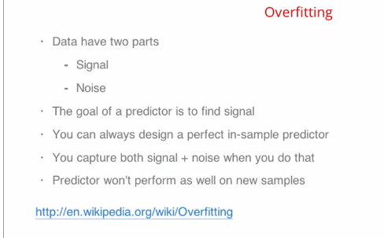

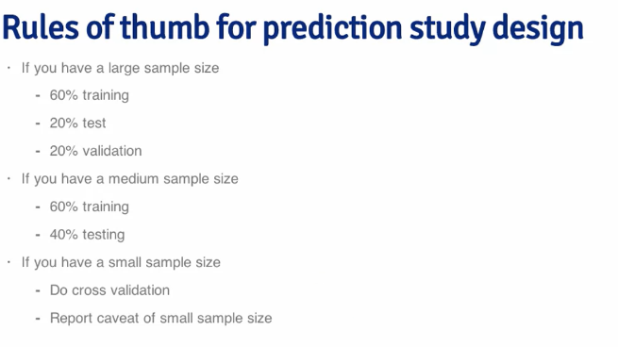

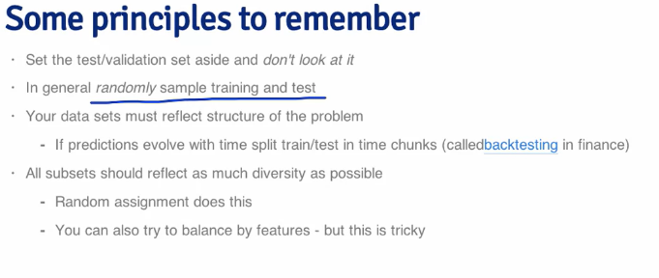

TYPES OF ERROR:

Basic Terms:

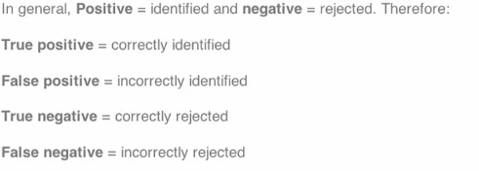

Explaining the above with an example:



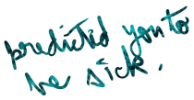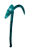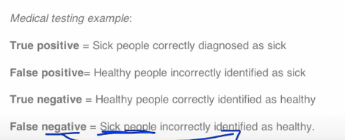



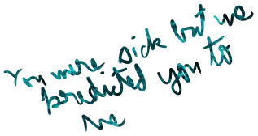

Key Quantities:

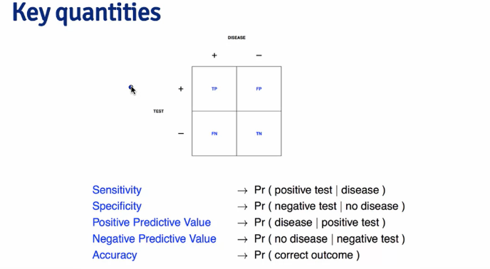

1.Sensitivity means diseased if a person is diseased , what is the probability that we get it right from our model?

2.Specificity means if a person is healthy , what is the probability we get it right from our model.

3. Positive predictive value means if our test shows that you are diseased, what is the probability that you are actually diseased or if we look at all the people we call diseased , what fraction of them are actually diseased.

4.Negative predictive value means that if our test/model shows that you are healthy, what is the probability that you are actually healthy.

5. Accuracy is the probability of the correct outcomes, in the table below , it is the true positives (TP) and the true negatives(TN) added up,

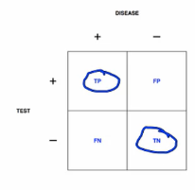

NOTE: In the Above table:

1.Say our prediction model predicted TP + FP people as diseased, out of that , from the lab results , we saw that TP were actually diseased whereas FP where healthy so TP was the correct prediction whereas FP was the wrong prediction.

2.Similarly Say our prediction model predicted FN + TN people as Healthy, out of that , from the lab results , we saw that TN were actually healthy whereas FN where sick so TN was the correct prediction whereas FN was the wrong prediction.



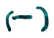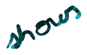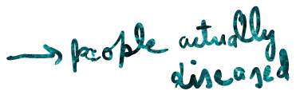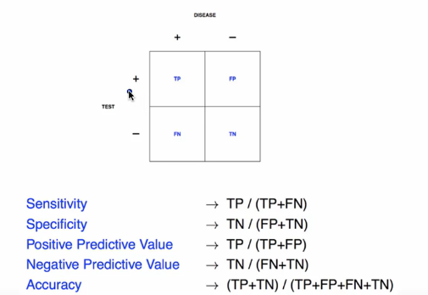



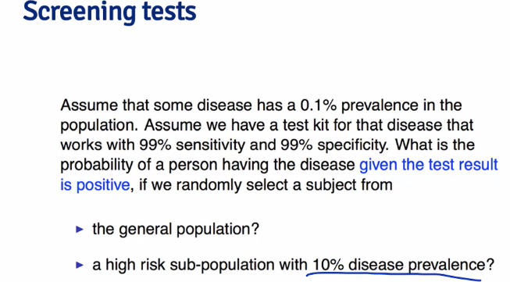

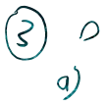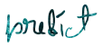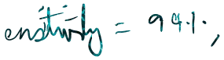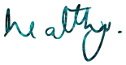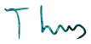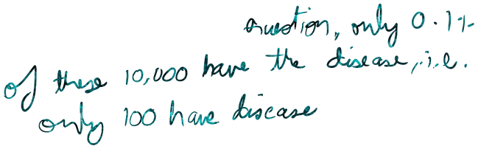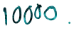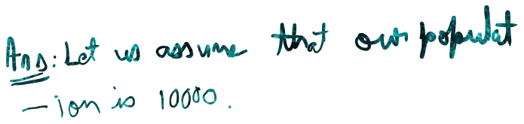

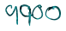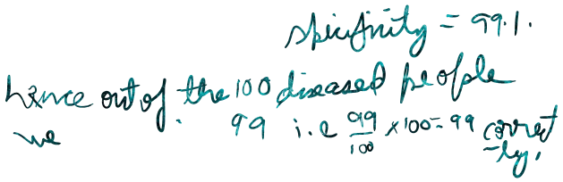

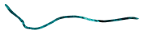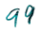

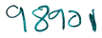

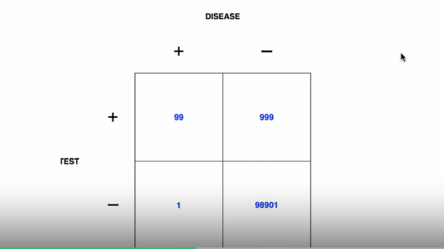

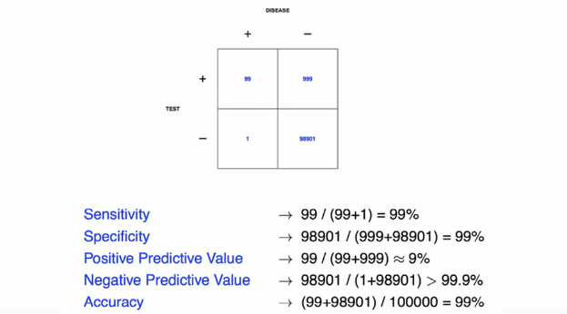

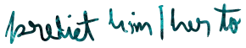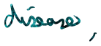

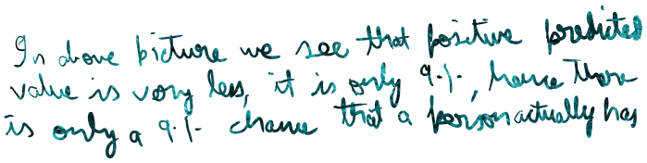



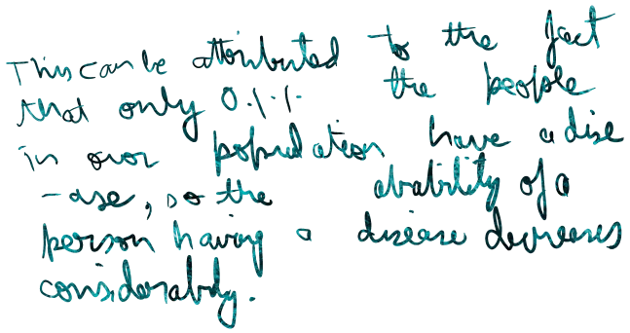

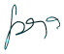

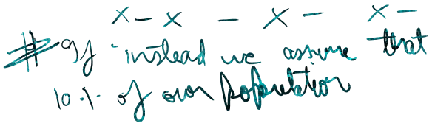

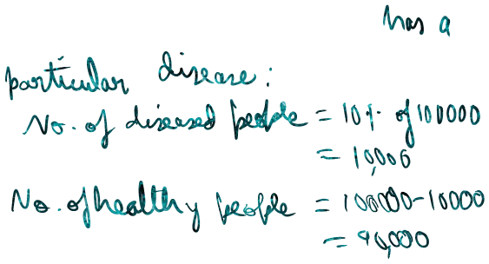

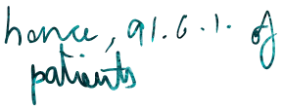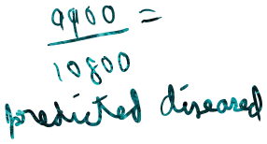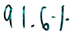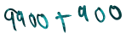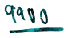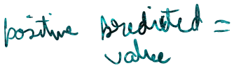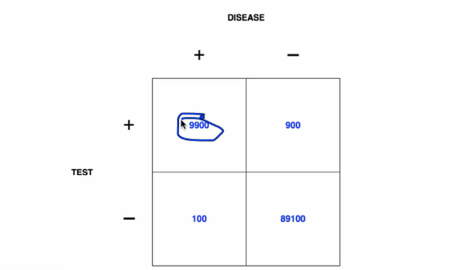



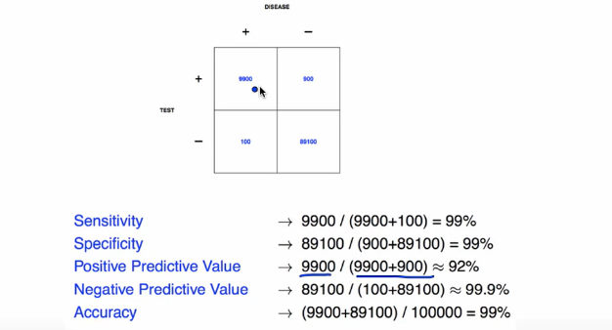

**ERROR IN PREDICTED VS TRUE VALUE:**

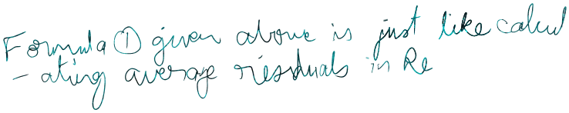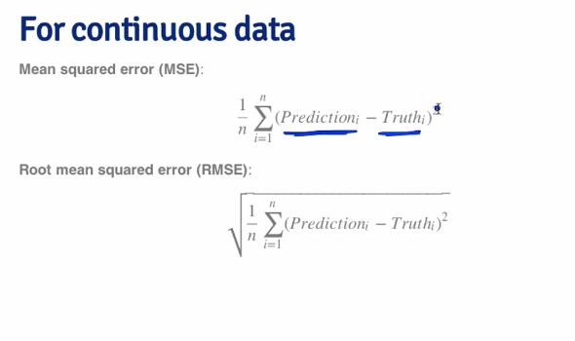





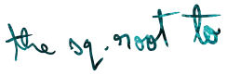

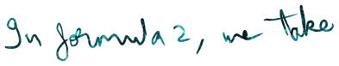





**Receiver Operating Characteristic curve OR The**

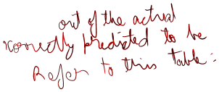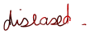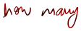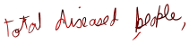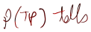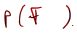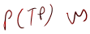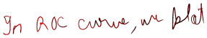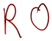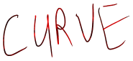

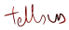

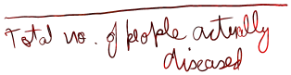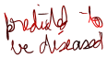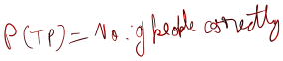

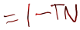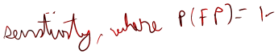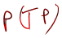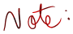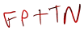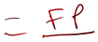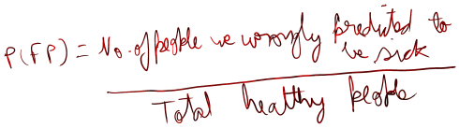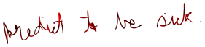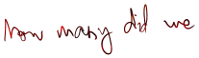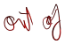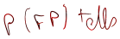

**ROC CURVE:**

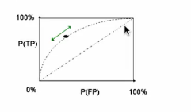

An actual eg of ROC curve:

 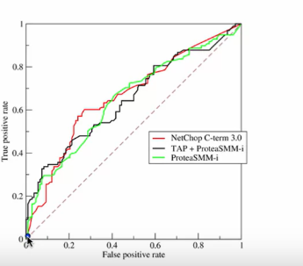

Here in the above curve , a false positive rate of 0.2 means a specificity of 0.8 whereas the point 0.4 => a sensitivity of 0.4 . Hence, this point has a high specificity but a low sensitivity.

COMPARING TWO OR MORE ROC’s:

What we want in our ROC is that it should have low False positive rate and high true positive rate both of which indicate high sensitivity and high specificity. Thus, we want our points to be on the upper left side of the curve. The point on the upper left corner has the highest specificity and the highest sensitivity.

We compare two or more ROC’s by looking at the area under the curve. High area indicates that the curve will be more towards the upper left side and hence the points lying on it will have high sensitivity and high specificity.

GENEREALLY:

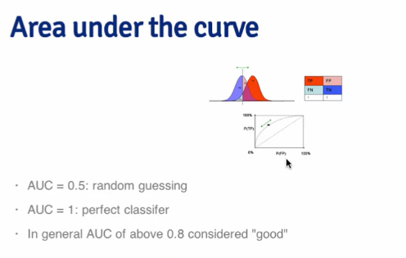

AUC = 0.5 is the dotted line and it indicates that is prediction is just random guessing, whereas AUC <0.5 indicates our prediction is worse than random guessing and the points on such a curve will be towards the lower right corner.

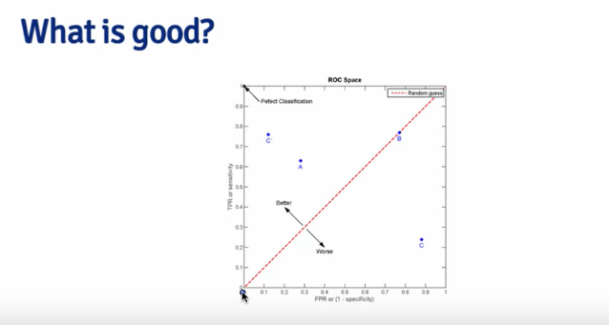



In the above picture, the highlighted point C is the best predictor followed by point A . Point B is just a random guessing predictor whereas point C below the dotted line is the worst predictor.

CROSS VALIDATION:



We subset our sample data which we are going to use to train the prediction model into a training set and a testing set. We do this because we can’t use another sample data as a test set while building the model since, this new sample dataset can then become a part of the training set and model can become acquainted with the noise there in this new dataset .

Hence we do all our testing while building the model on the training data set only by sub- setting it.

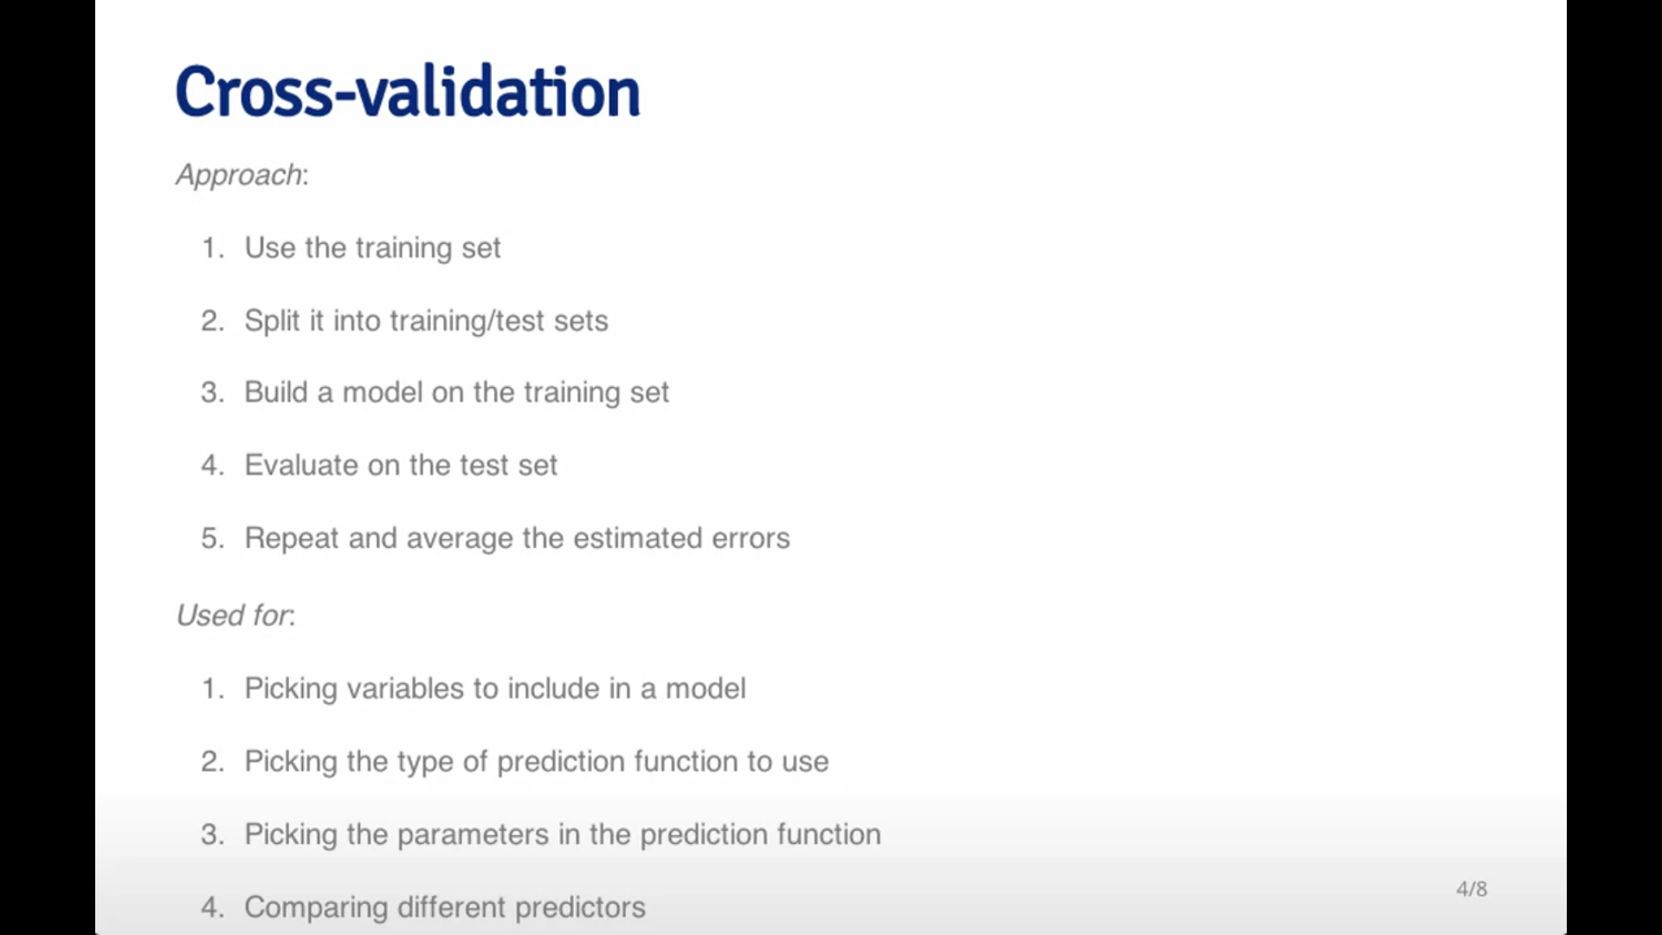

*METHODS OF SUBSETTING:*



1. RANDOM SUBSAMPLING:

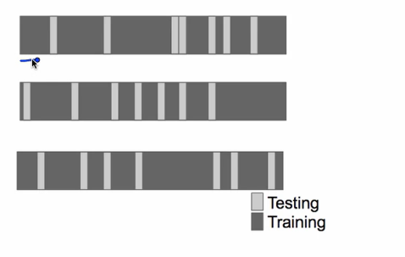

#We randomly divide the data into testing and training datasets.

#We use the black coloured values to train our model and try to predict the grey coloured values to test the accuracy of our model.

2. K-FOLD SUBSAMPLING:

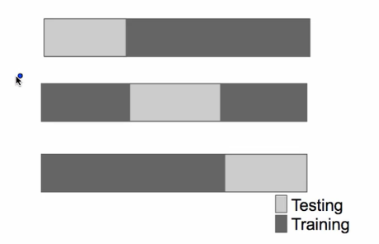

Above is an example of 3 fold testing. We divide our data into 1/3 testing , 2/3 training then into 1/3 training ,1/3 testing ,1/3 training and then into 2/3 training , 1/3 testing and do the training of black parts and testing on grey parts.

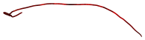3. LEAVE ONE OUT SUBSAMPLING:  
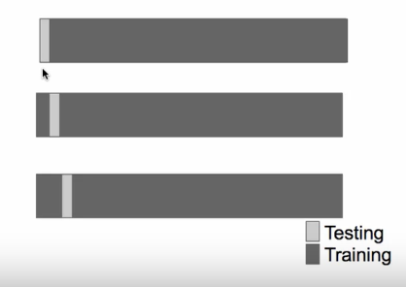

a) We leave one sample out each time for testing and do the training using the other samples.

b) In the first picture, we leave the first sample out for testing and use other for training.

c) In the second picture, we leave the second sample out for testing and use other samples for training.

d) We do this until we reach the end of the dataset.

SOME THINGS ABOUT CROSS VALIDATION TO KEEP IN MIND

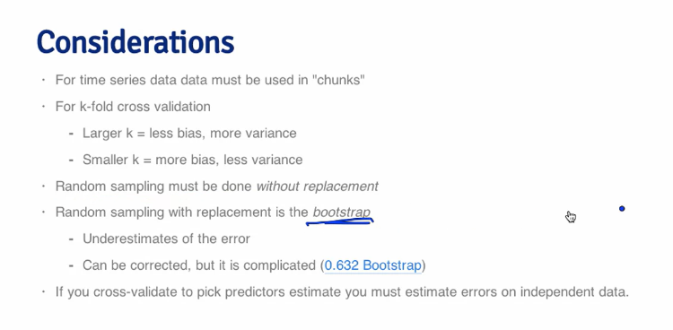

Supervised learning:



1.In supervised learning we give the programme certain amount of information and it trains itself it using and tries to predict further things.

Eg: 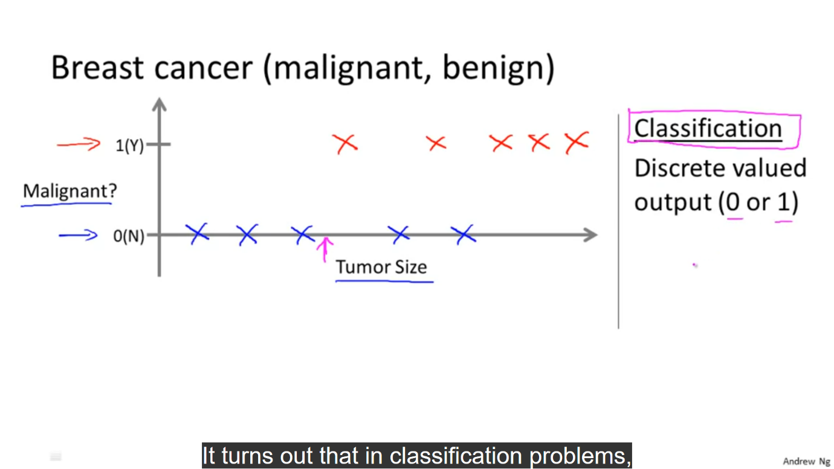

Here the x axis corresponds to certain tumour sizes and y axis tells that whether a tumour is malignant(1 on the y line )i.e. harmful or benign(0 on the y line) i.e. harmless.

We have inputted some pre-existing values pertaining to tumours -identified in the graph by blue and red crosses into the programme. The programme now tries to classify the point p as malignant or benign on the basis of the information we have inputted.

Eg2:

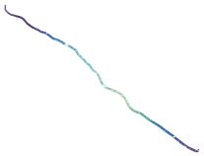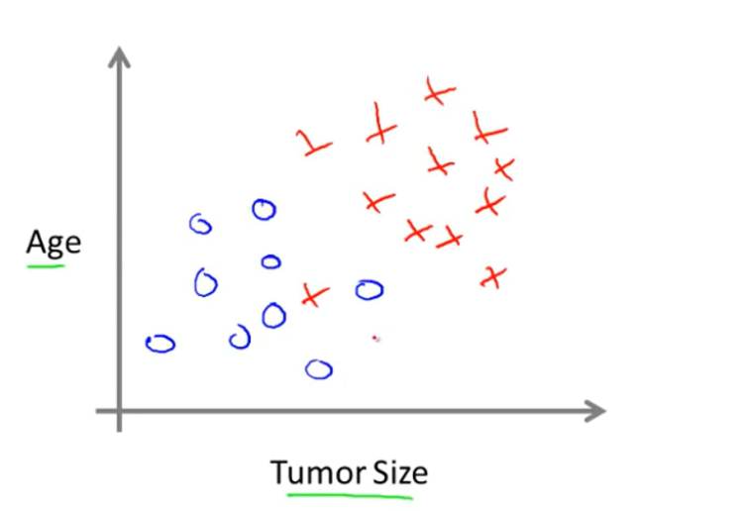

Here we try to find the relation between age and tumor size. The blue dots represent benign tumors and the red crosses represent malignant tumors.

If we ask the programme to classify point p as malignant or benign , it would first try and separate crosses and dots from each other and then try to classify p.

Classification:



It means grouping data into discreet values like 0 , 1 ,2 etc.

Eg: In eg 1 given above, benign tumors are represented by 0 and malignant tumors by 1.

UNSUPERVSIED LEARNING:



In unsupervised learning we present the programme with just the data , which has not been grouped or classified. We ask the programme to classify it.

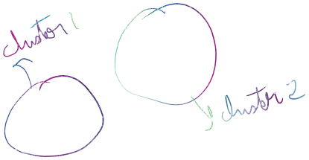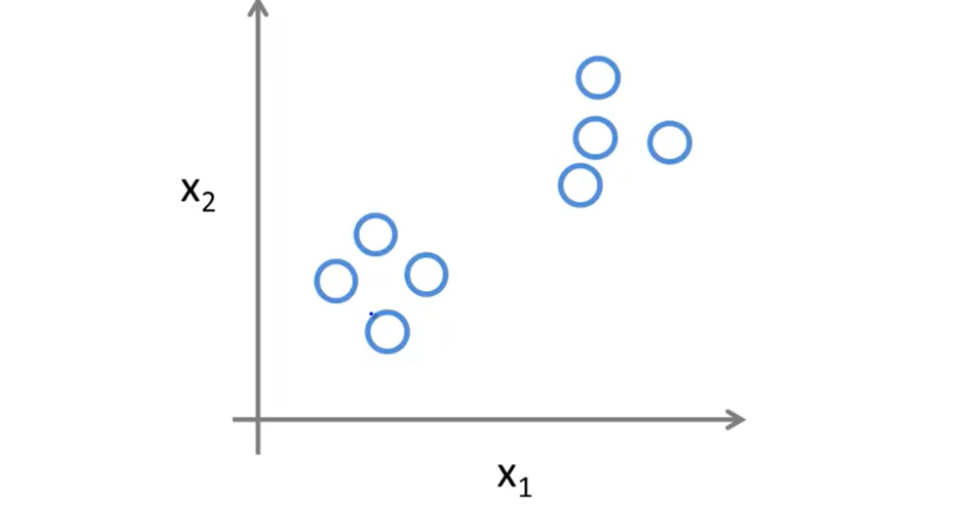

Here we ask the programme to classify the points plotted on the graph . The programme may classify the points as cluster 1 and cluster 2.

Another example may be that we may have two audio recordings with two overlapping voices. Suppose voice 1 is more significant in audio 1 and voice 2 in audio 2. Now we can ask the programme to separate voice 1 and 2 from both the recordings . Now after the separation recording 1 has only voice 1 and recording 2 has only voice 2. This is an example of unsupervised learning.

MODEL REPRESENTATION:



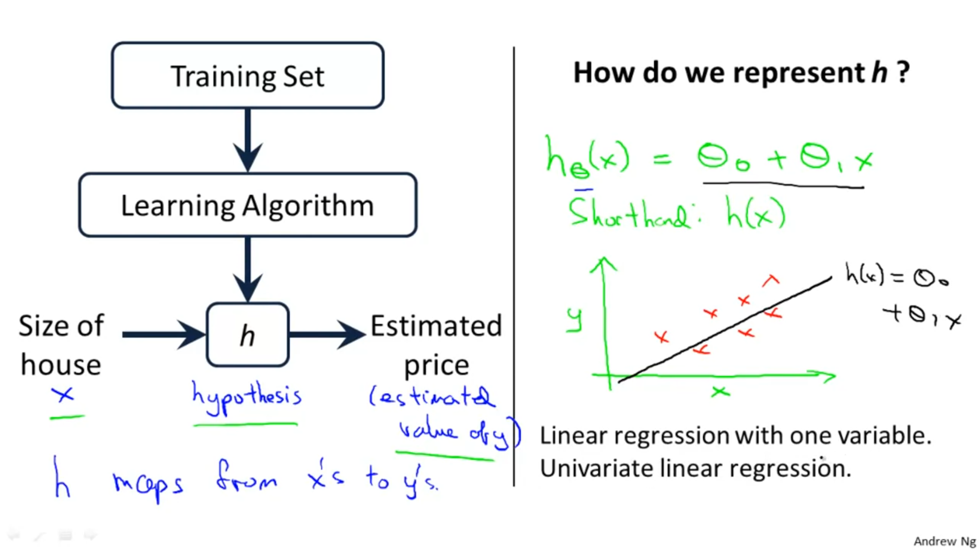

COST FUNCTION:  
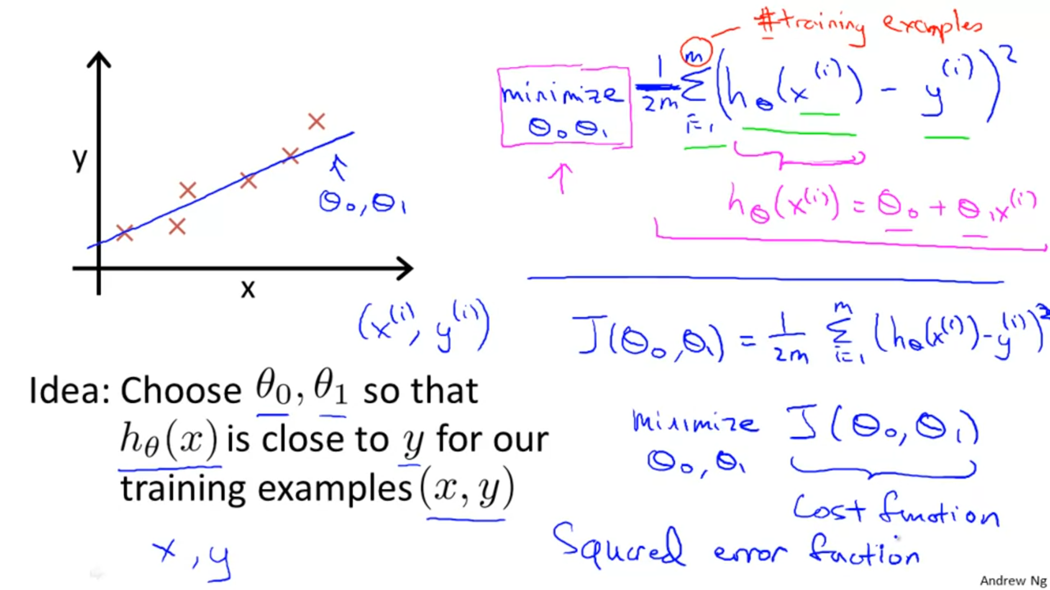



Cost function is also known as the squared error function:

##sLet us consider our constant to be 0 , so the equation becomes:



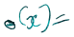

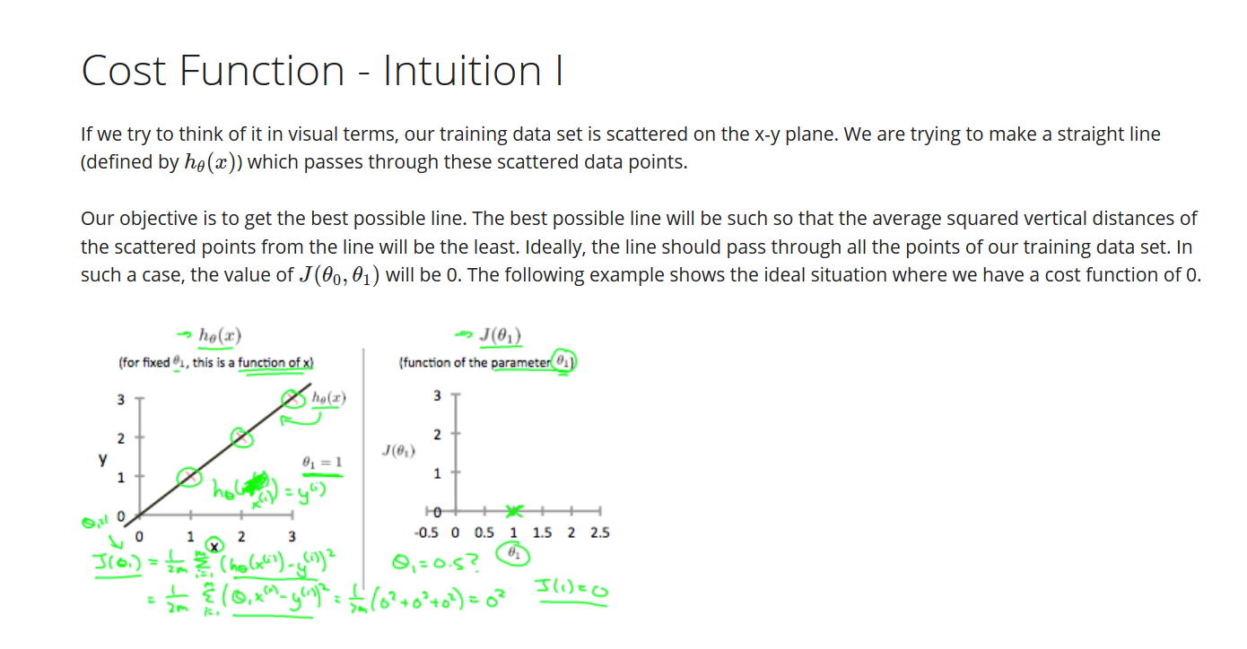

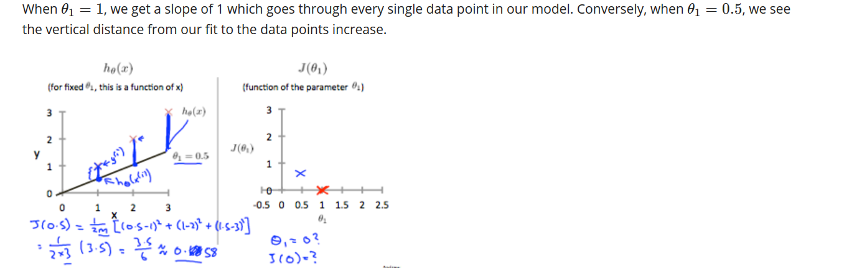

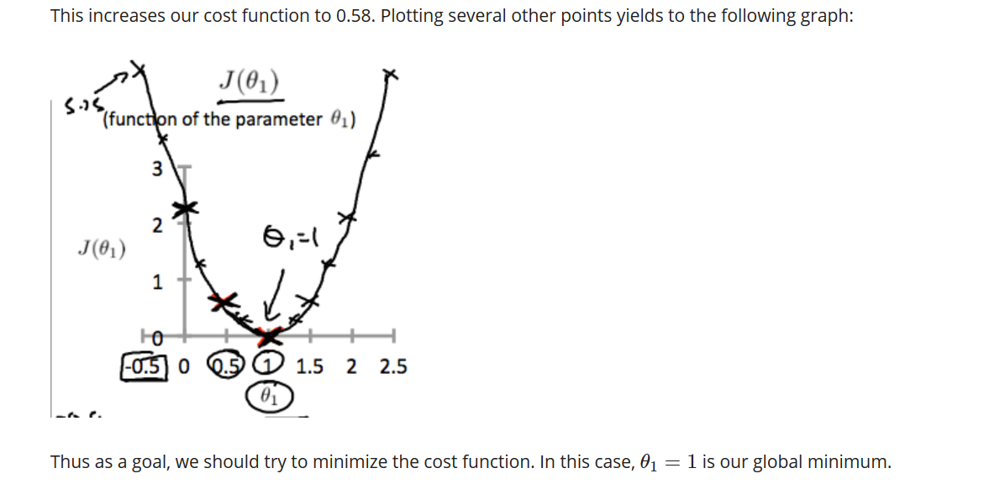

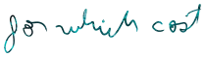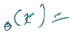And hence

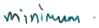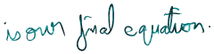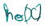



Now let us assume our equation to be:

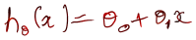

Our aim to find the value of for which the cost function is minimum.

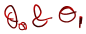Graph of cost function vs

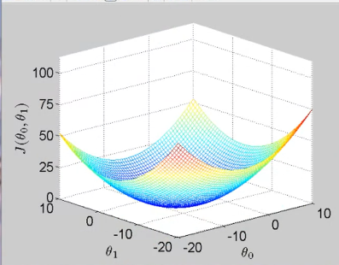

We infer from the above graph that a particular value of the cost function can be achieved through different combinations of different values of

For eg , the value 25 of the cost function may be achieved through various combinations of values of

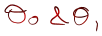 .

Above visualization in 2-d using contour plots:

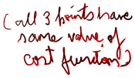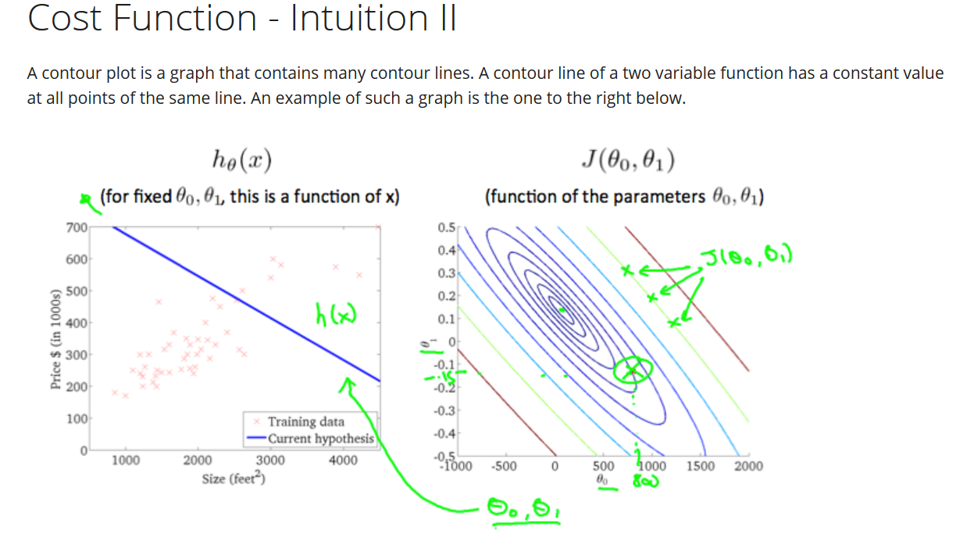

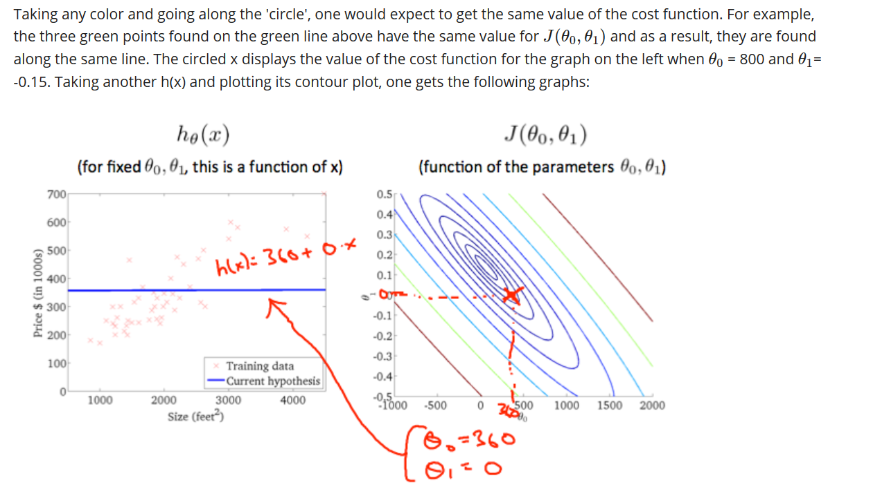

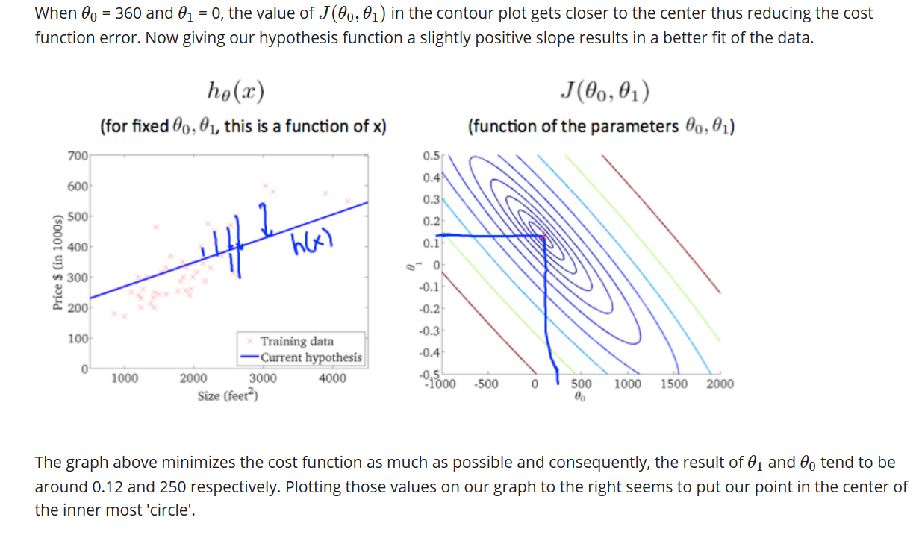

**GRADIENT DESCENT**



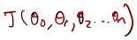Gradient descent is a technique used to find minimum value of any function

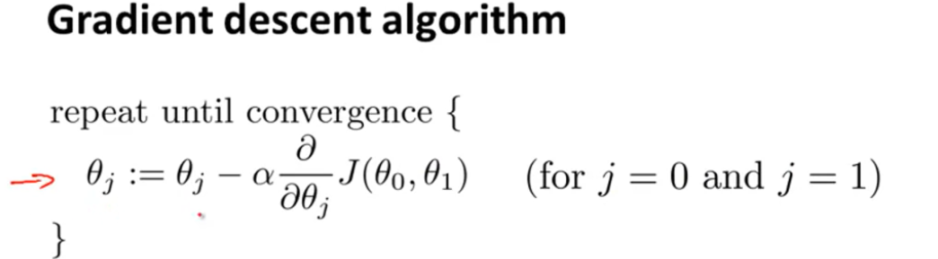

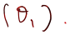First we look at a very simple example where we have a function

Now, we have to minimize the value of this function.

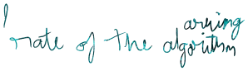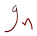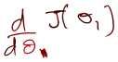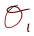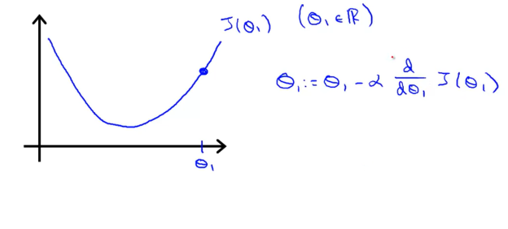

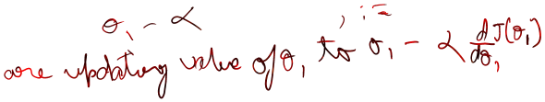

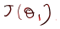Updating theta1 means that we are changing value of theta 1 till we reach the minimum value of theta1 which in turn minimizes the function

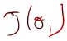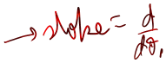

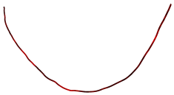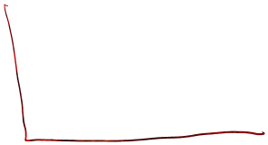



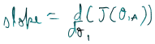Let slope at point A = a. Hence,

As we move from point A to point B, changes:

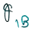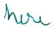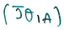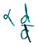

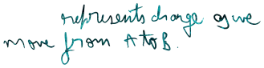

NOTE: Higher the value of slope alpha, faster the change in theta1.

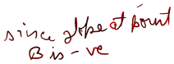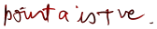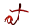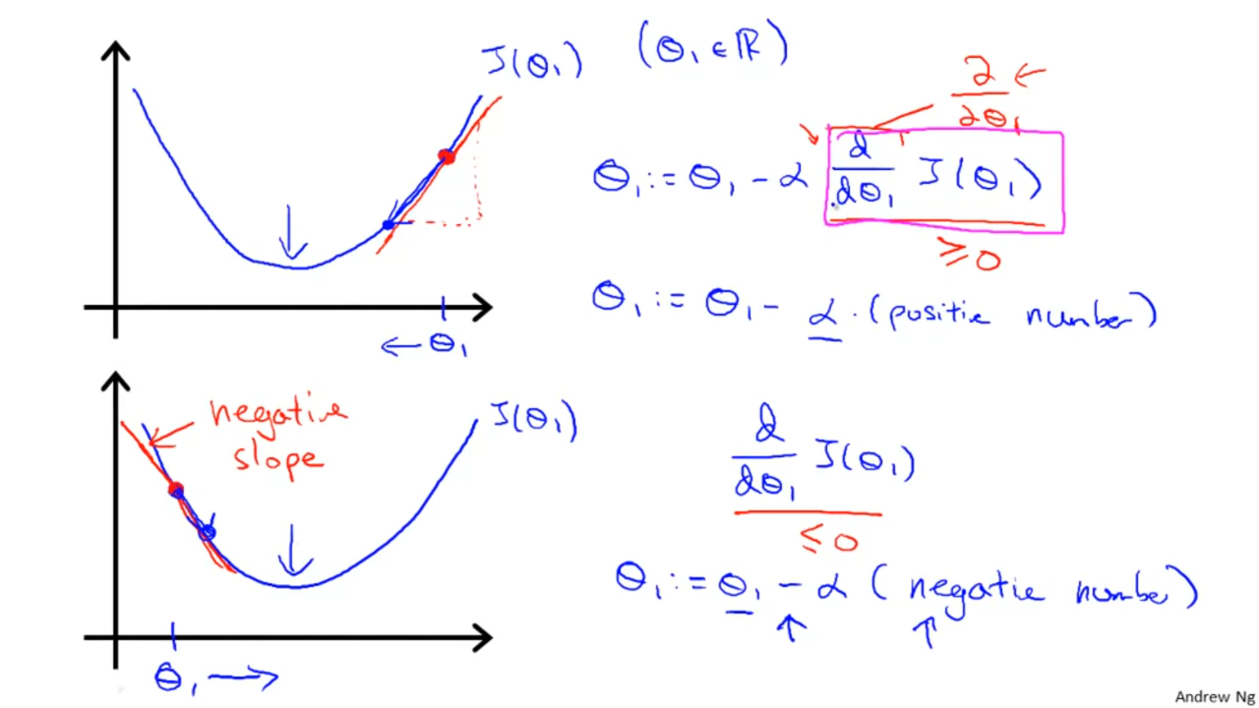

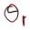In graph 1 , value keeps on decreasing as we move from point A to point o (point of minima).

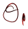In graph 2, value keeps on increasing as we move from point B to point o.

Some imp. points pertaining to alpha:

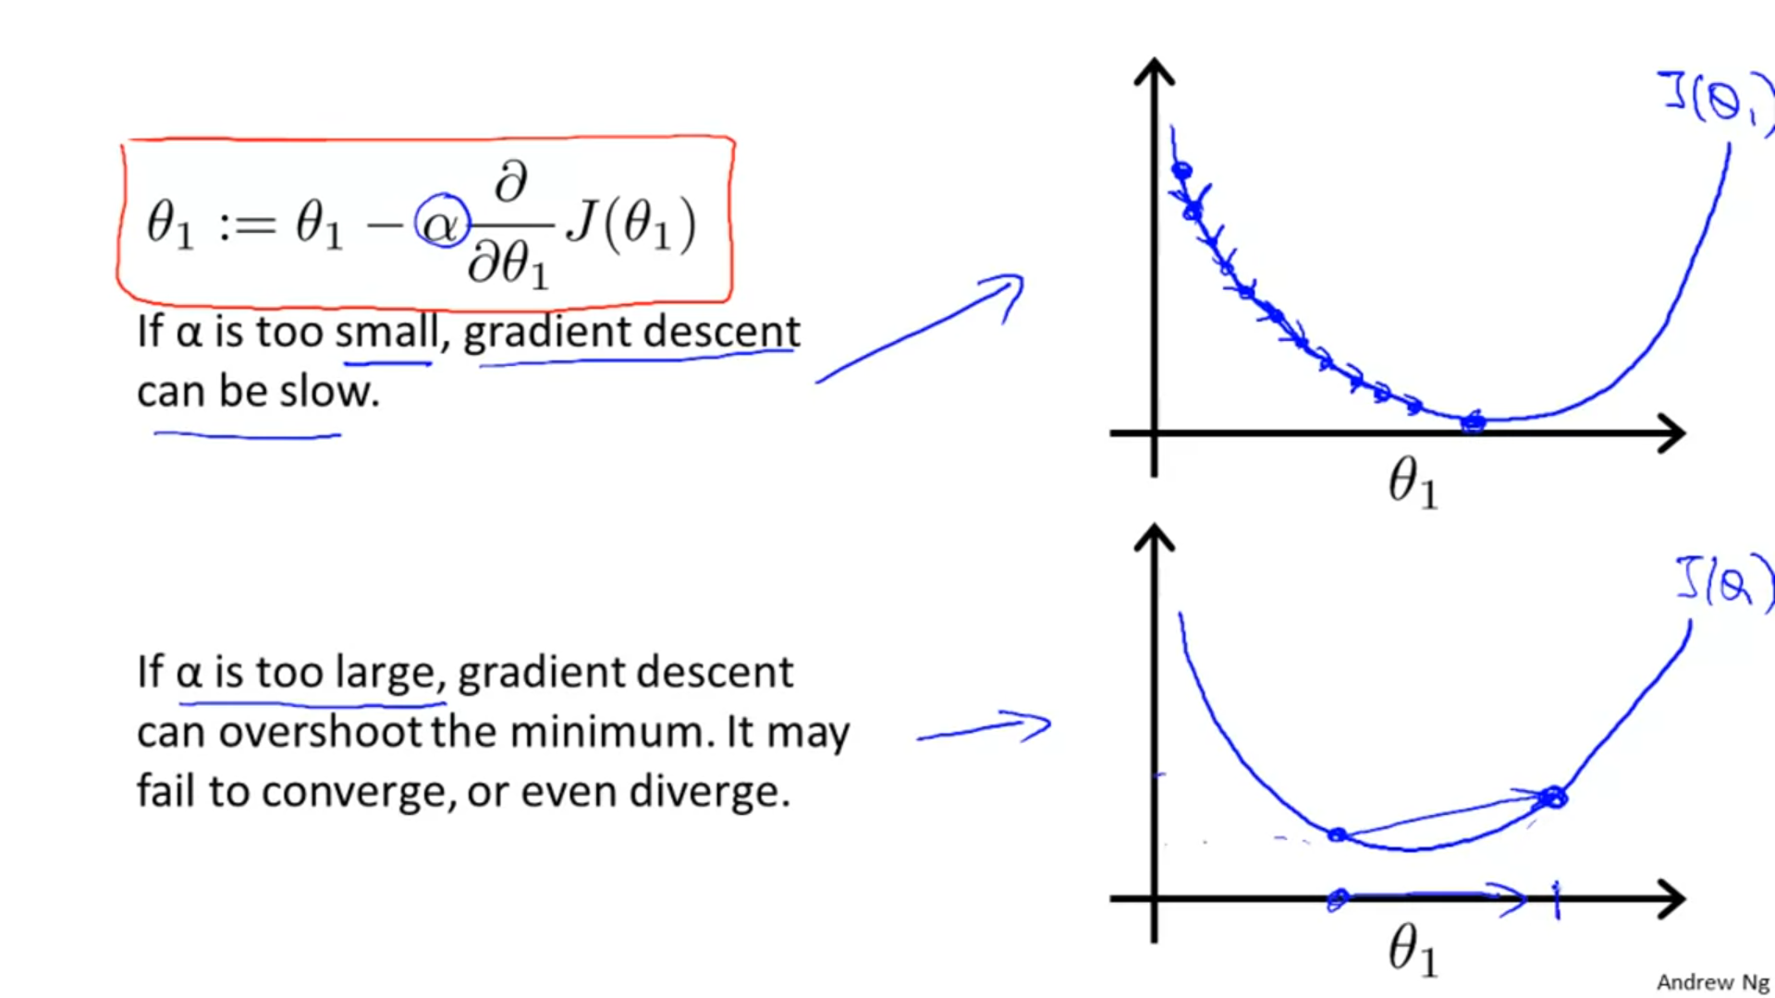

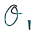In graph 2 , as we change try to go from point A to point O (point of minima), there is positive change in value of i.e. value of increases yet we do not reach point O and reach point B since value of alpha is so large , then we try to come back to point O but since alpha is so large , we reach a point C , and then point D and so on. Eventually we see we keep getting farther and farther from point O instead of getting closer to it.

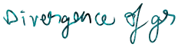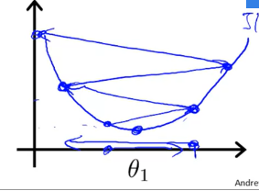



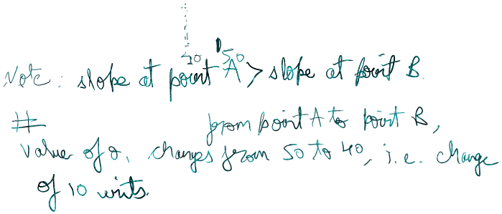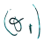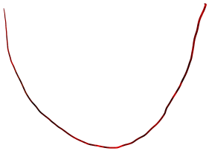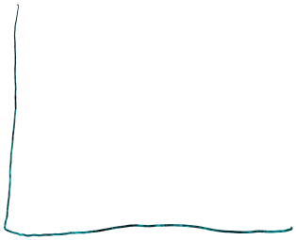

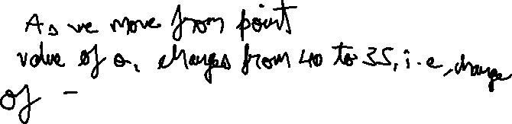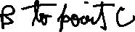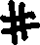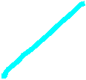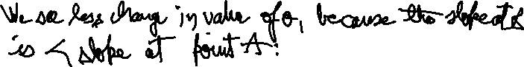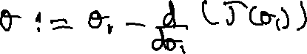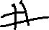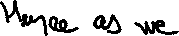

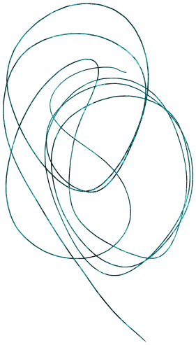

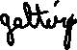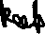



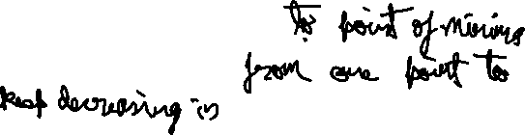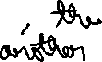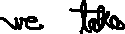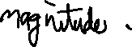

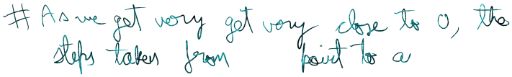



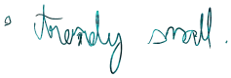



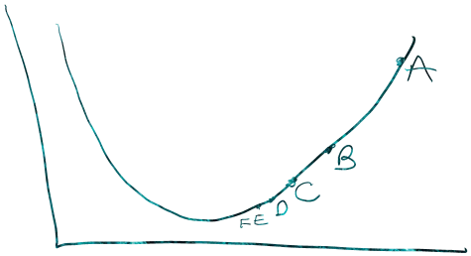

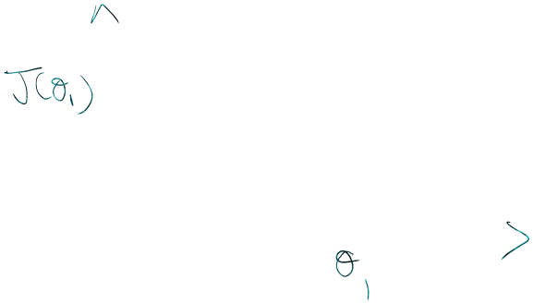

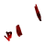



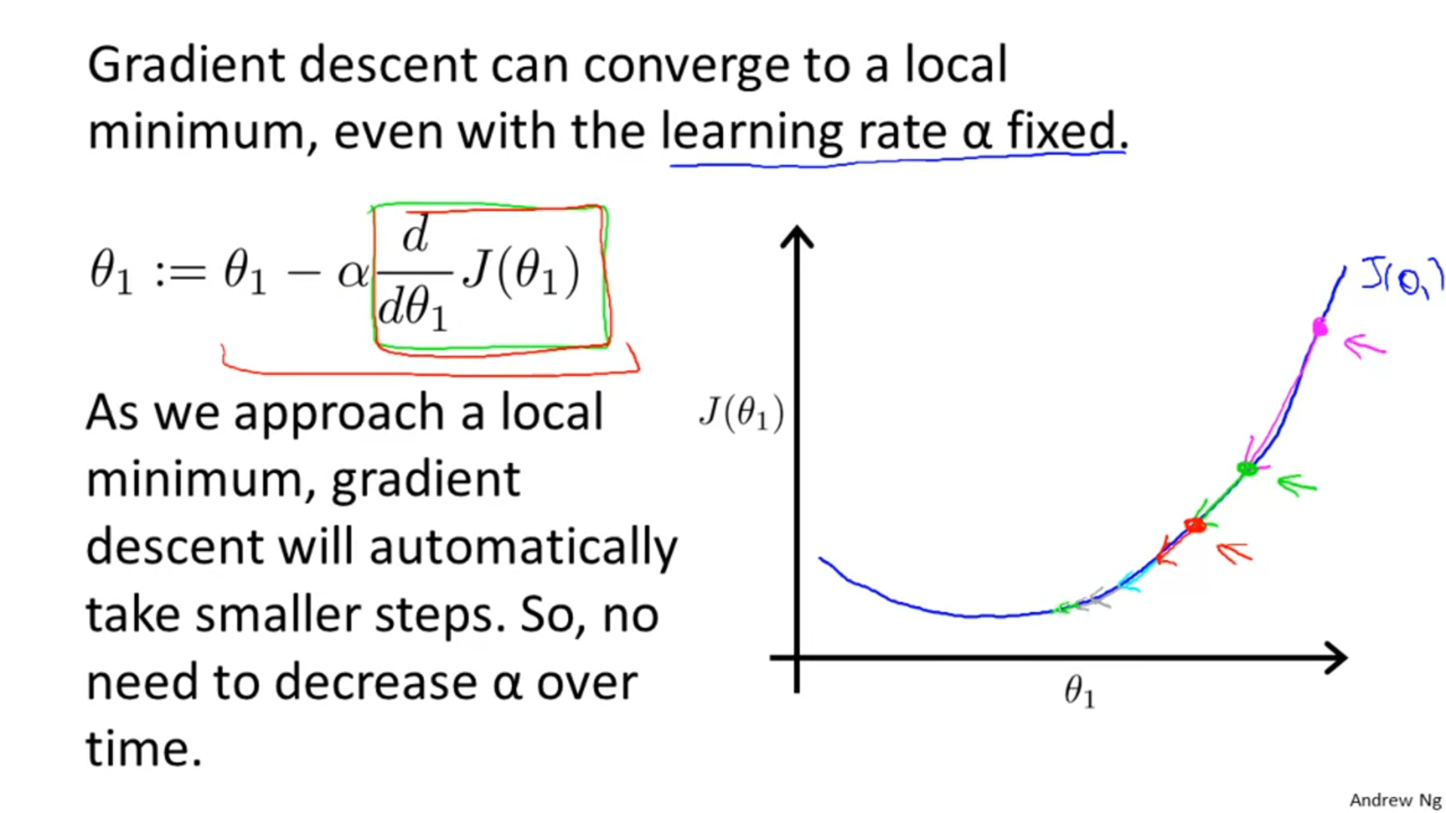s

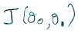Now , We see another example in which we have the function

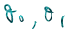We want to reach point of minima for which the function has minimum value for the given

Let us assume we are at point A which is represent by the cross on the graph of the function:

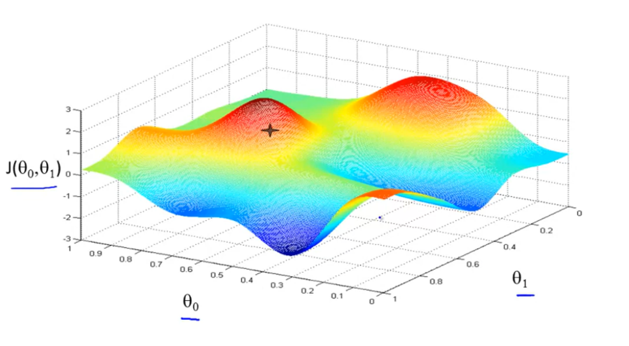

Now, we want to reach the point of local minima. Let’s suppose that in this pursuit of reaching the point of minima, we start taking baby steps down the slope from point A .

We keep going until we reach a point O.

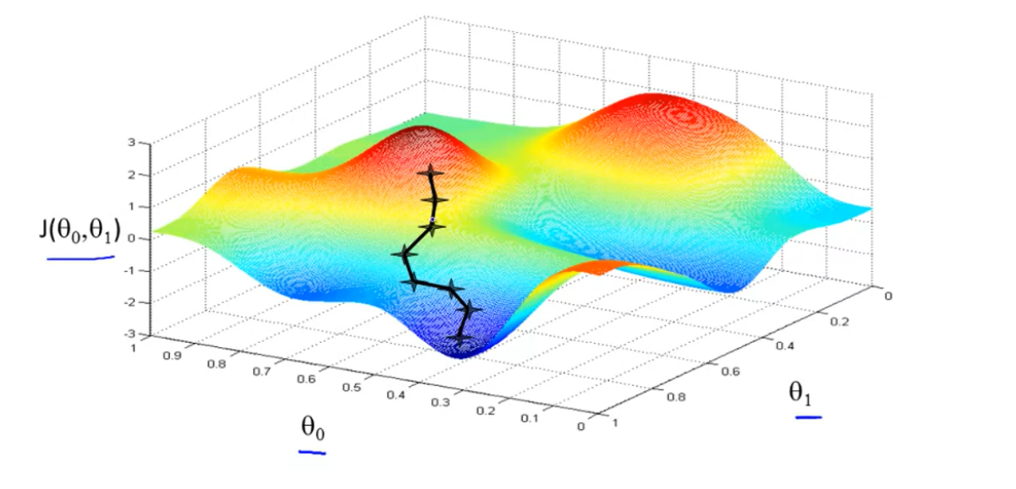

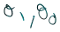As we take each step starting from point A , value of changes with each step till we reach the point of minima.

##If we would have moved a bit towards right from A and then started moving downwards , we would have reached a different local minima.

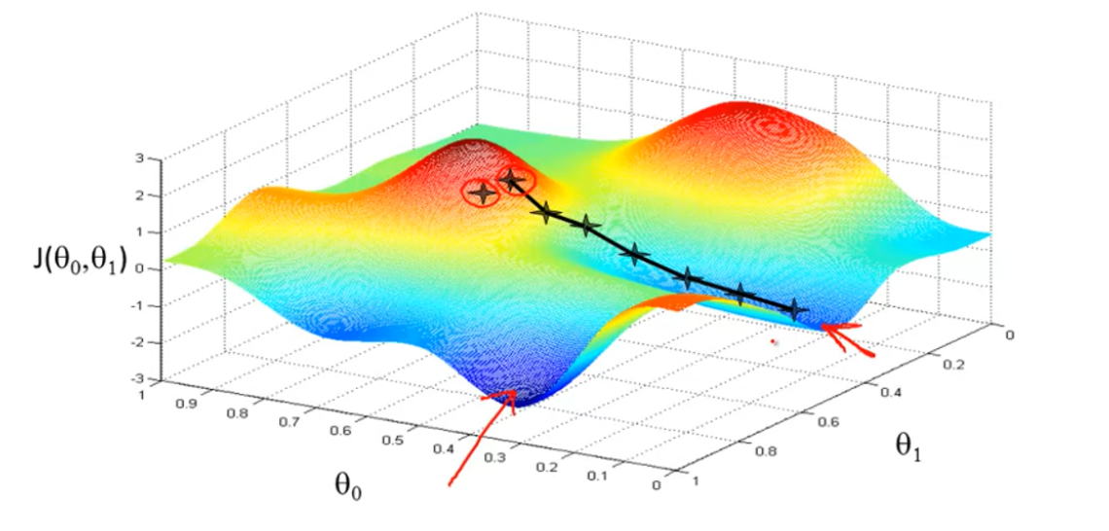

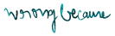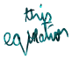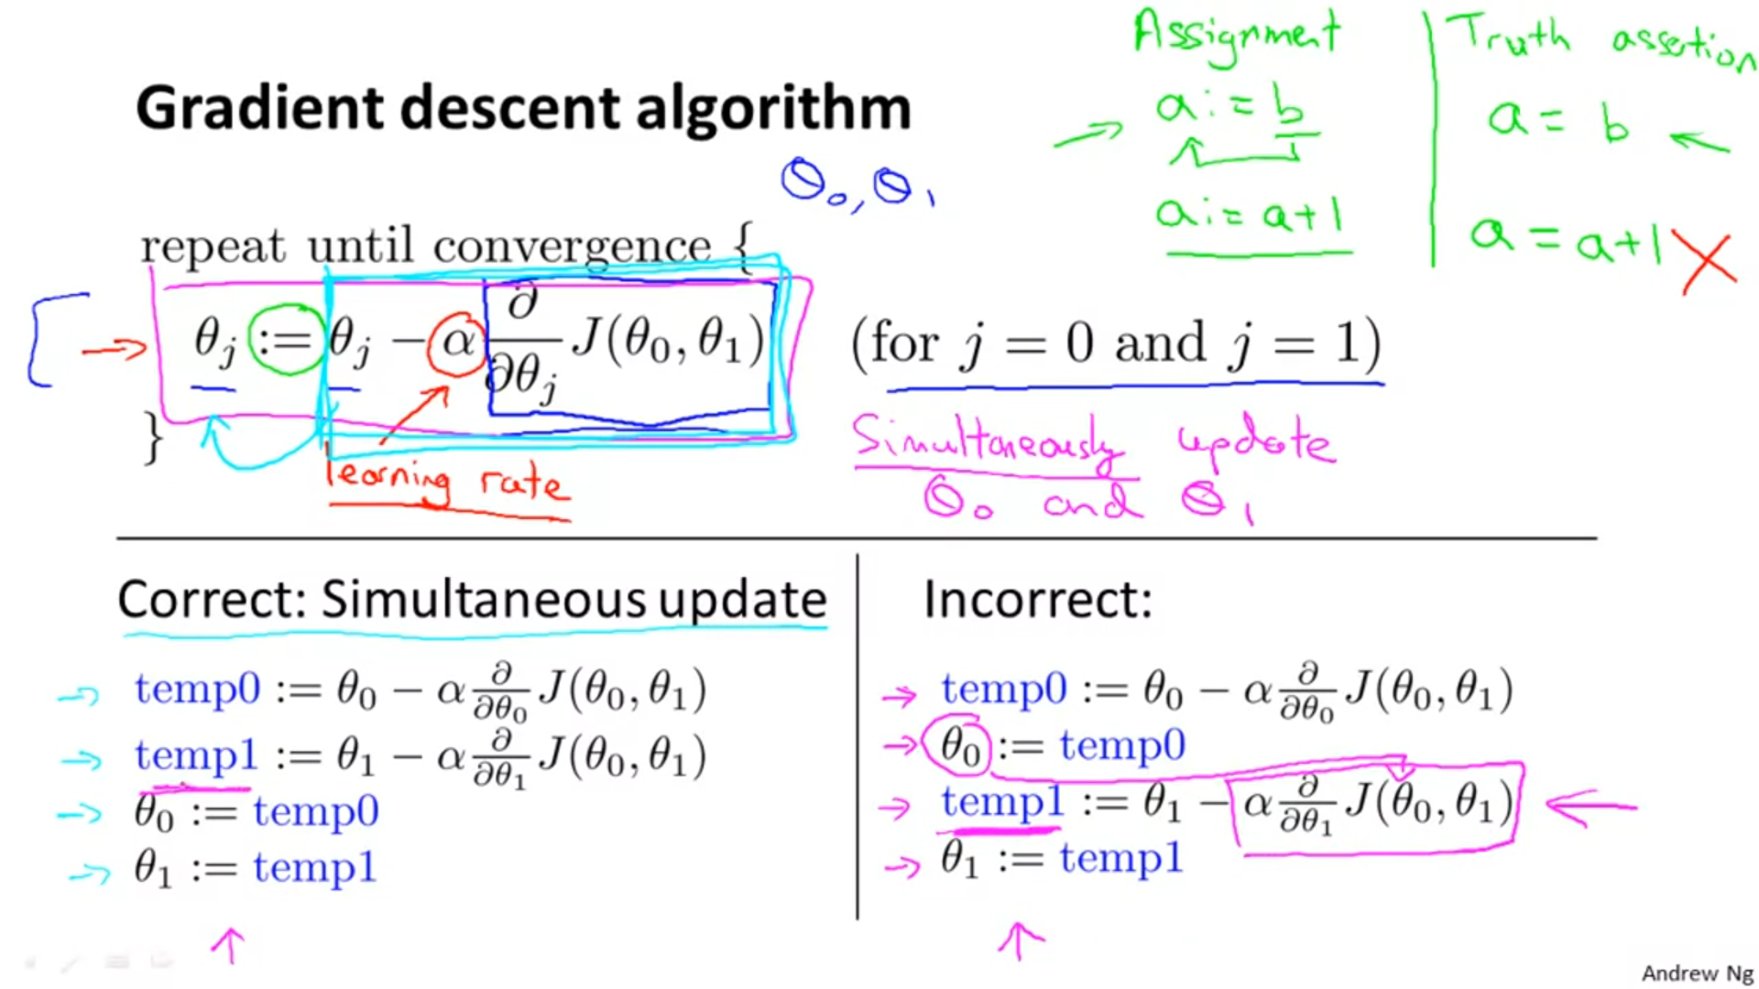

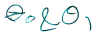**Getting updated value of at each step as we move from any point to the point of minima:**



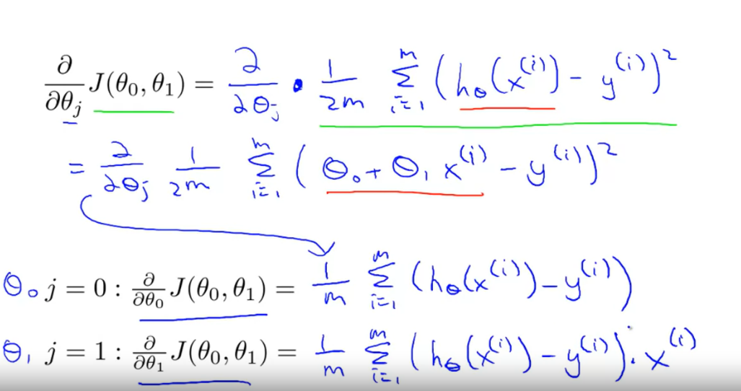

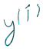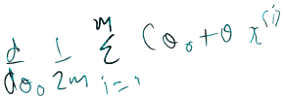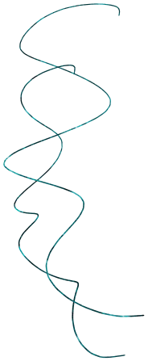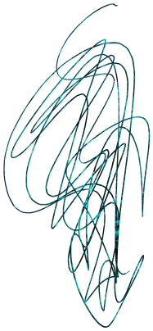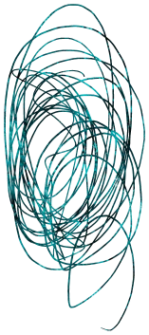Explanation:



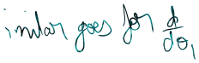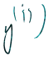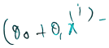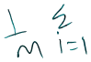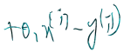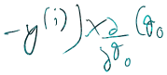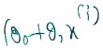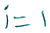

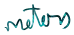

Note: Above logic can also be extended to multivariate regression:

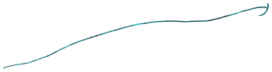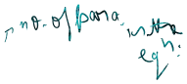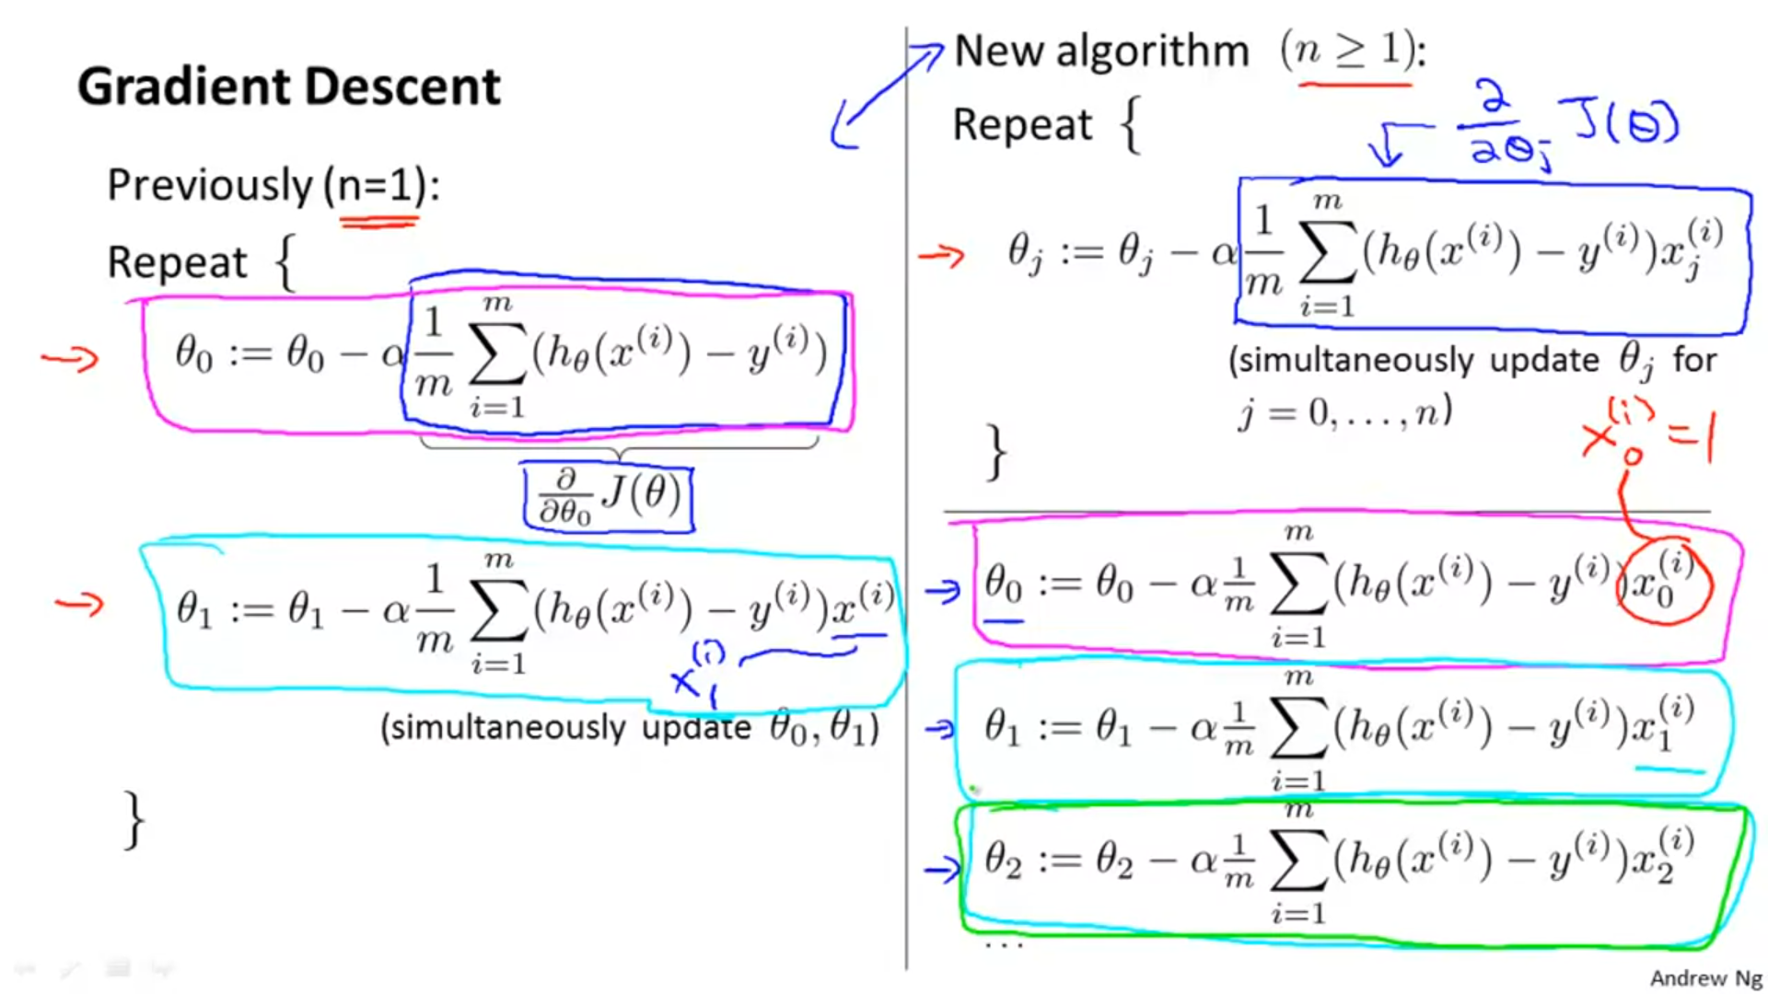

Note: Superscript (i), is not usually not used to denote rows or columns but simply refers to the ith training example. For eg: x(2) , refers to training 2nd example.

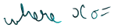Let us assume the equation has 2 variables i.e. n=2.

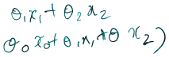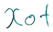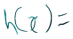



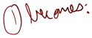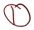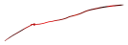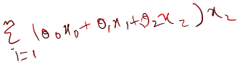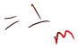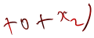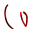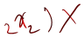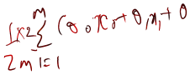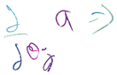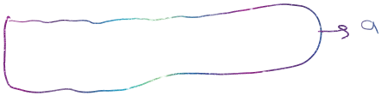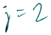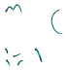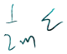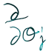

**QUESTION:**



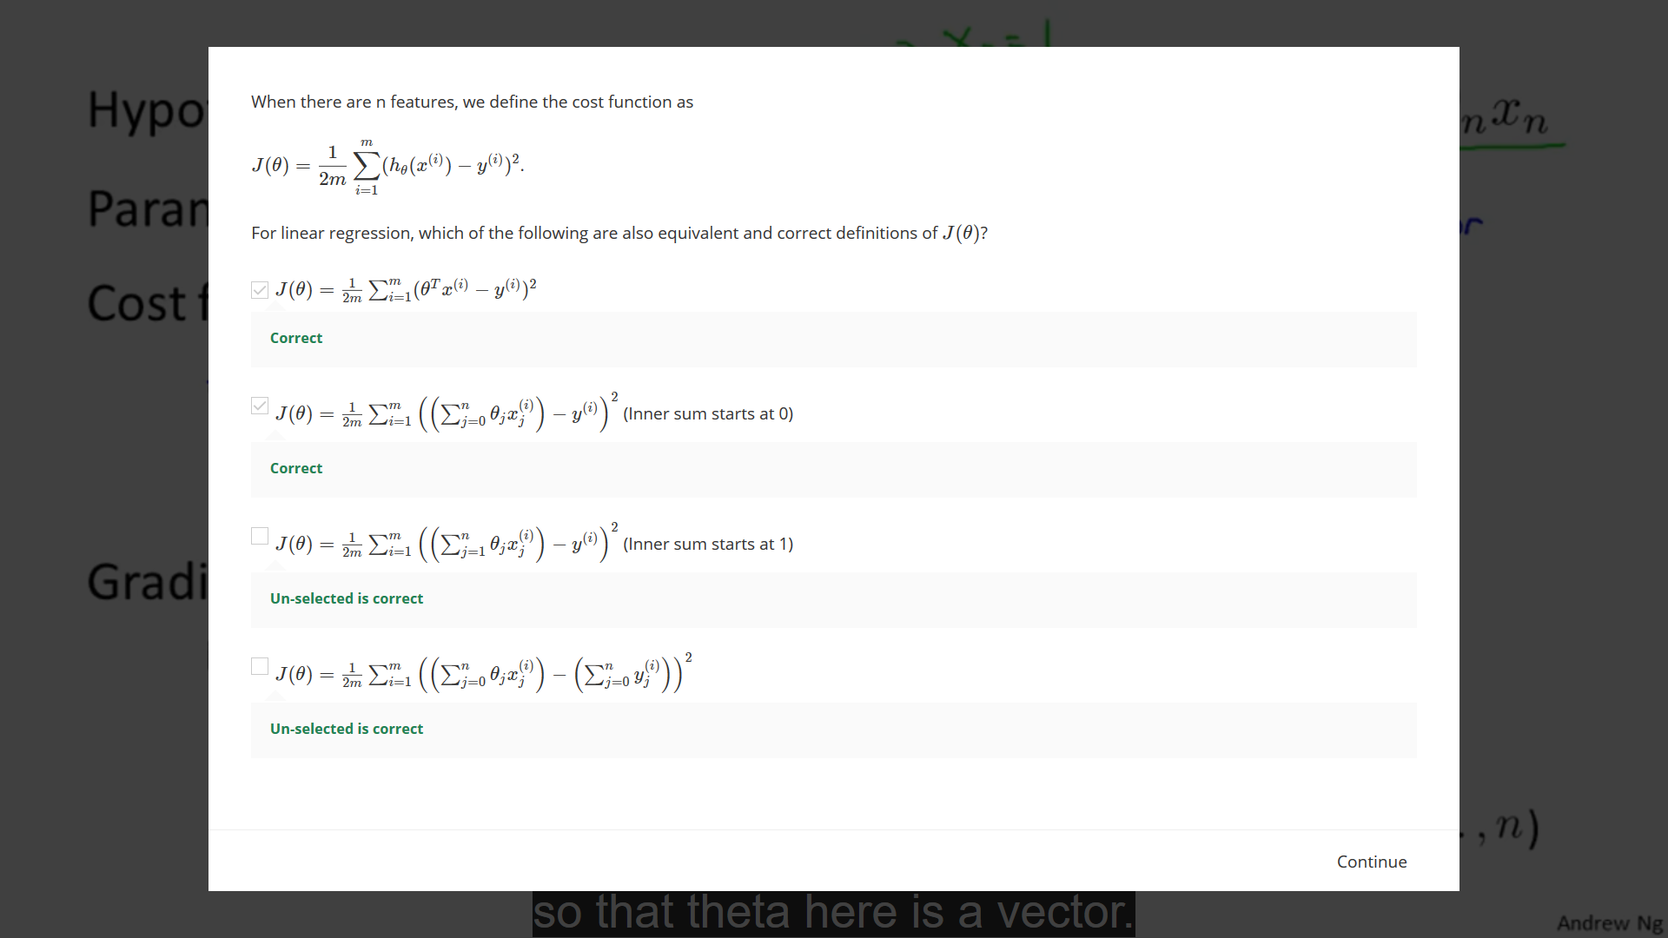

**Theta always converges to the point of local minima due to gradient descent:**



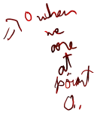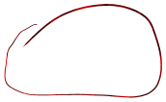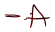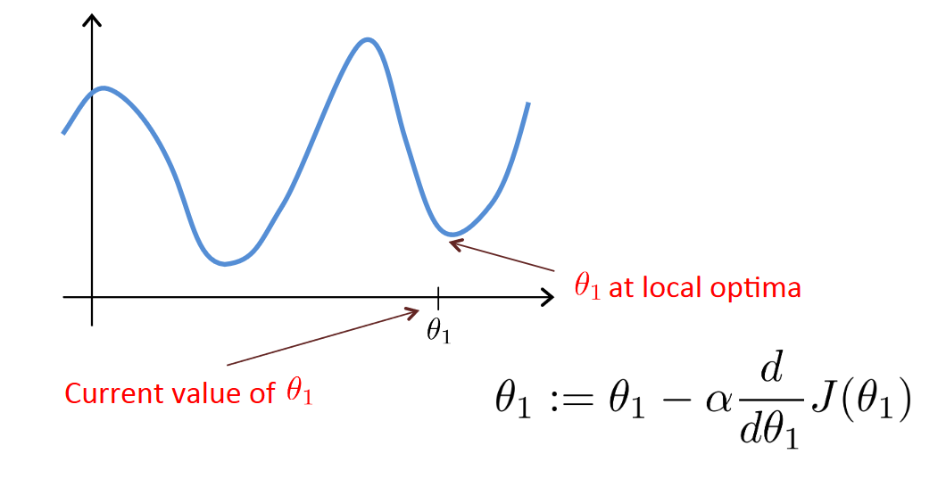

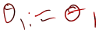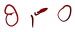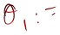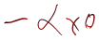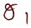Let us assume that we start from point A and proceed towards point O. We know O is the local minima , while point B is the global minima. As we reach point O , there can be no further change in value of theta1 this is because slope at point O is = 0 , hence in accordance with the above given formula , change in theta 1 = 0. Since

**COST FUNCTION FOR LINEAR REGRESSION:**



It turns out that that the cost function for linear regression is always going to be a bow shaped function like this:

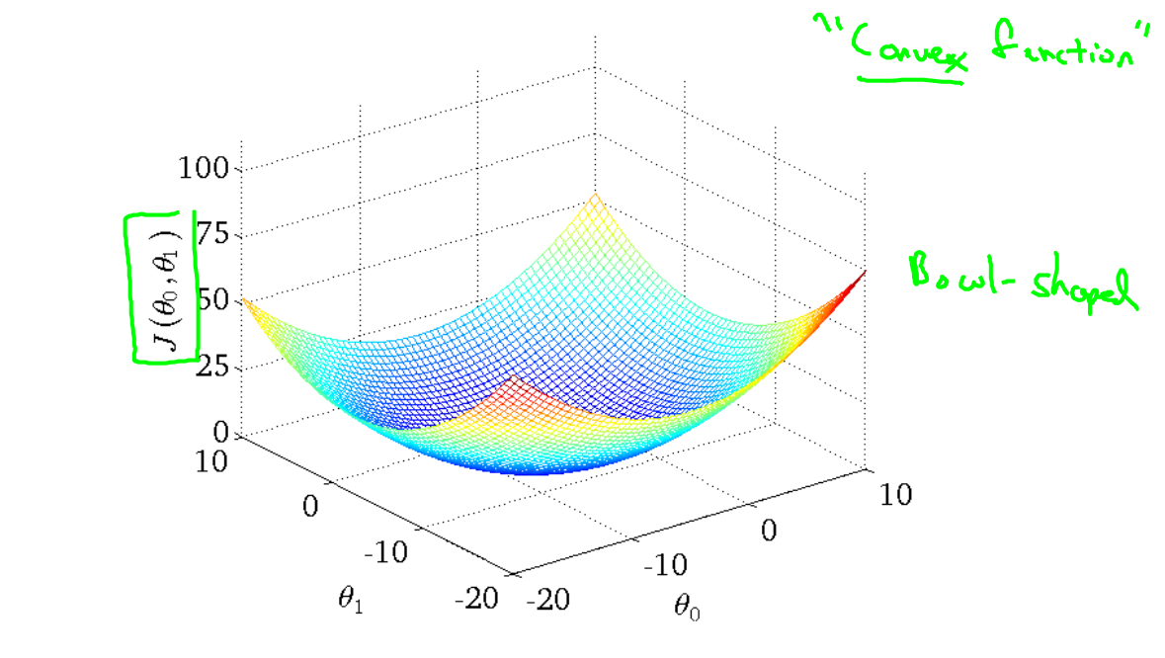

The technical term for this is that this is called a convex function.

**AN EXAMPLE SHOWING GRADIENT DESCENT IN WORK:**

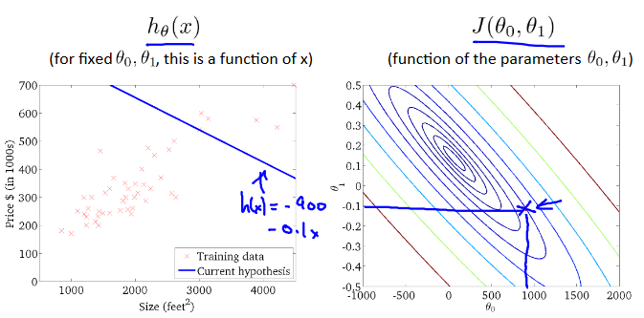

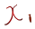

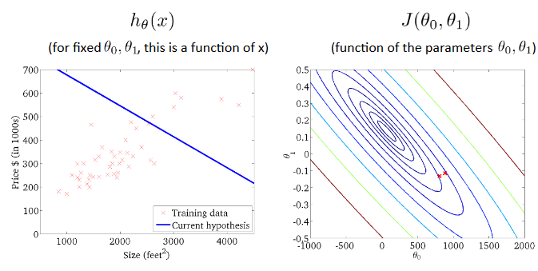

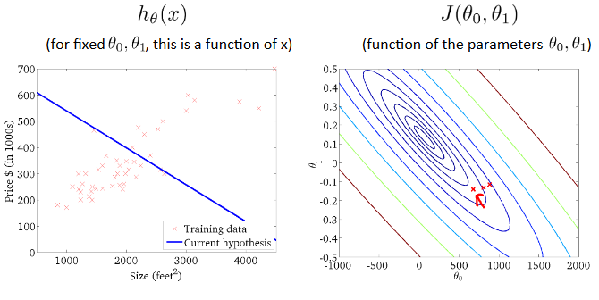

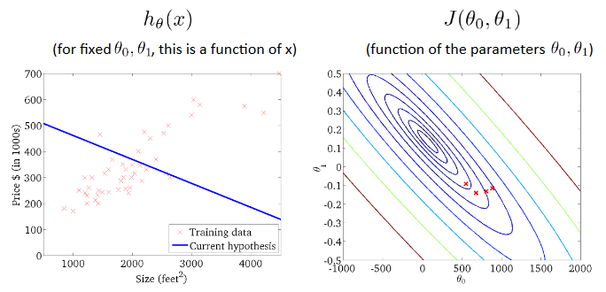

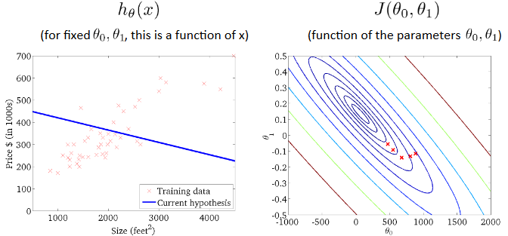

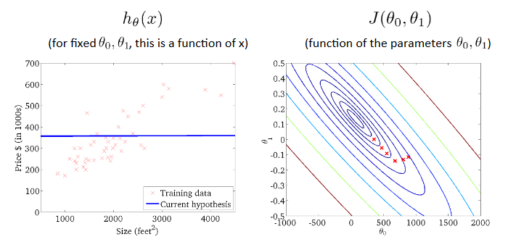

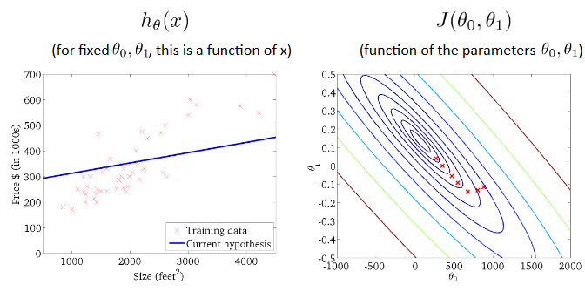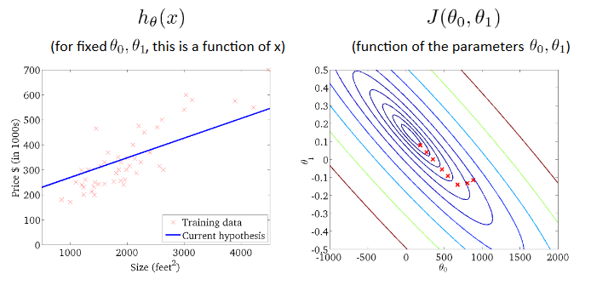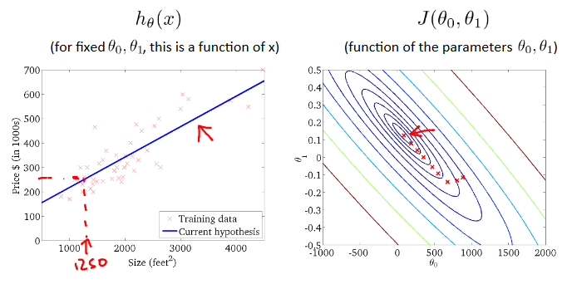

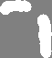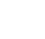

In the above pictures as we keep getting closer to the perfect fit we start getting closer to the centre of the contour plot i.e. , the point of minima.

**FEATURE SCALING:**



Why do we need feature scaling?

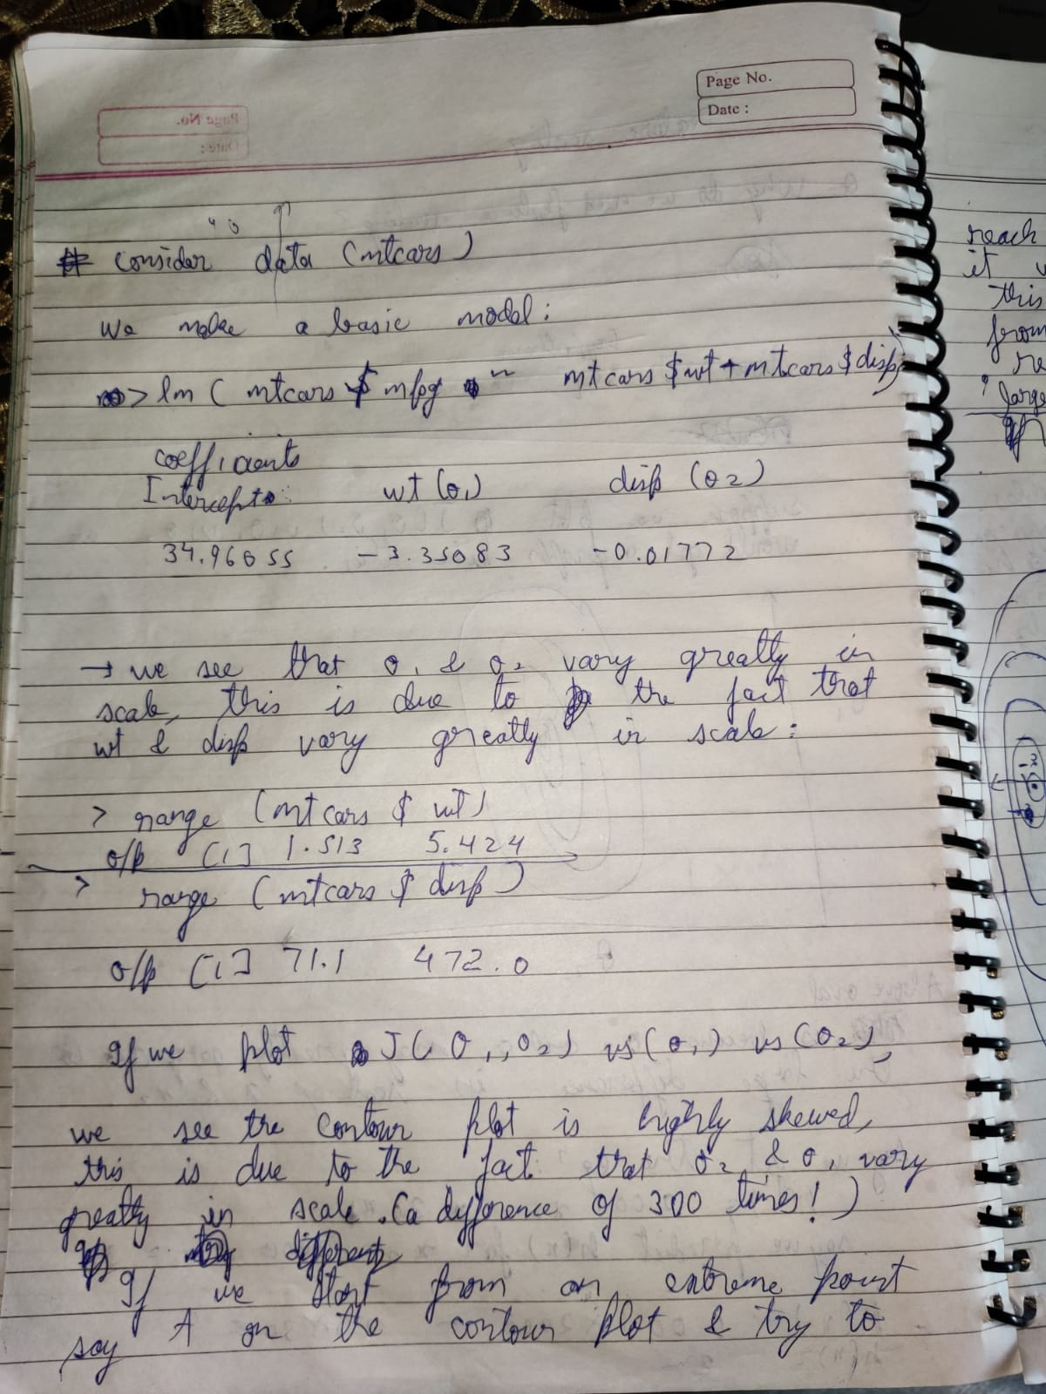

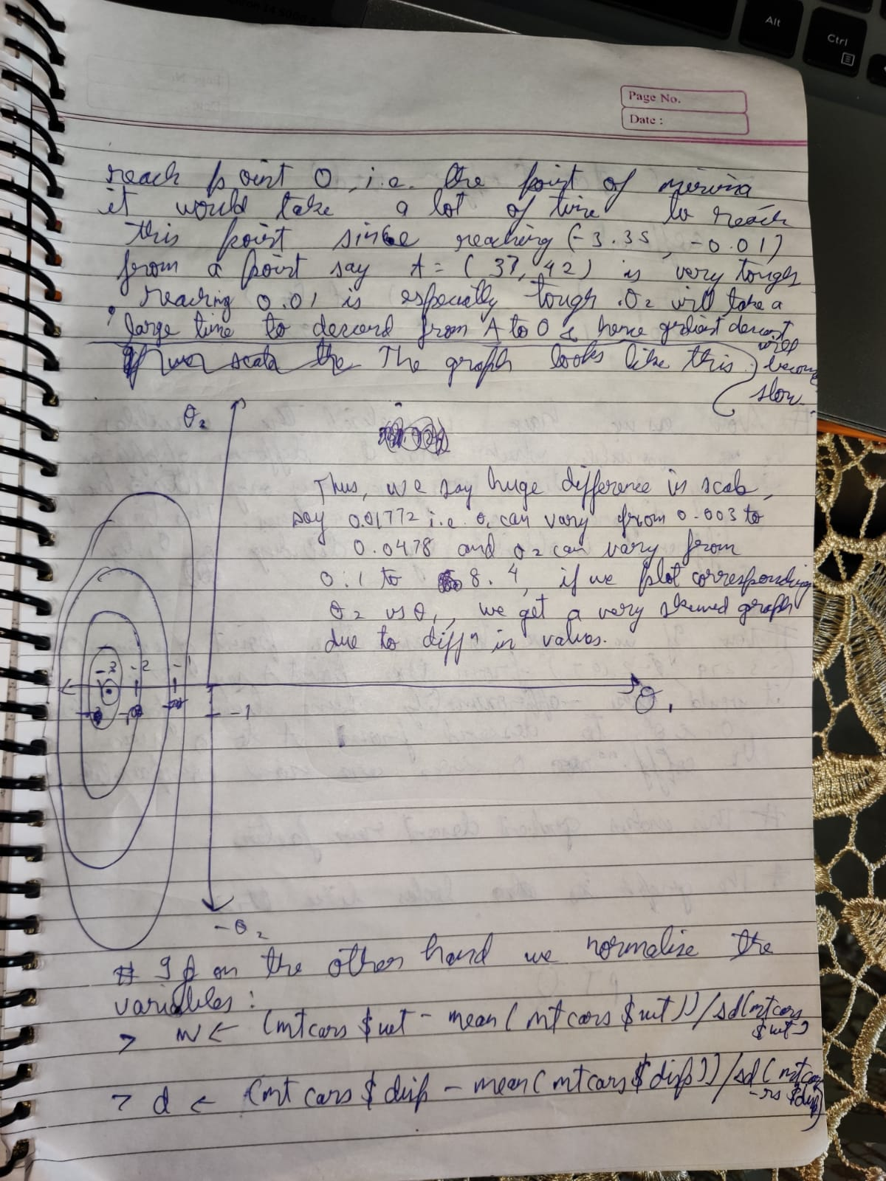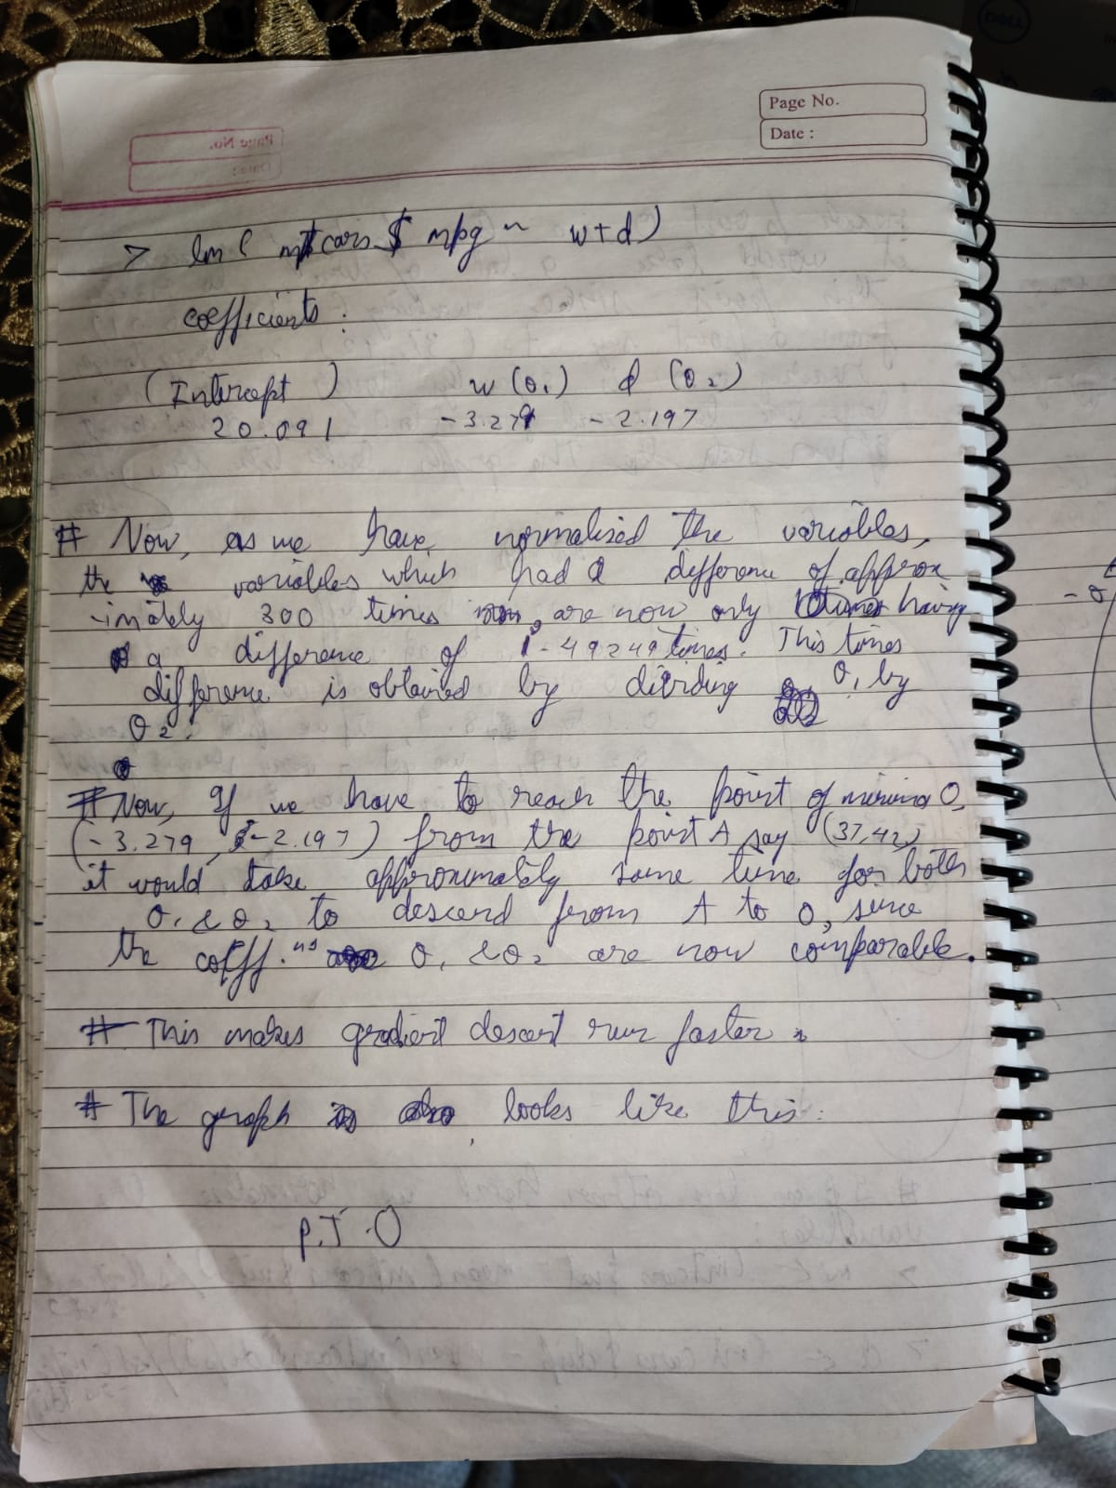

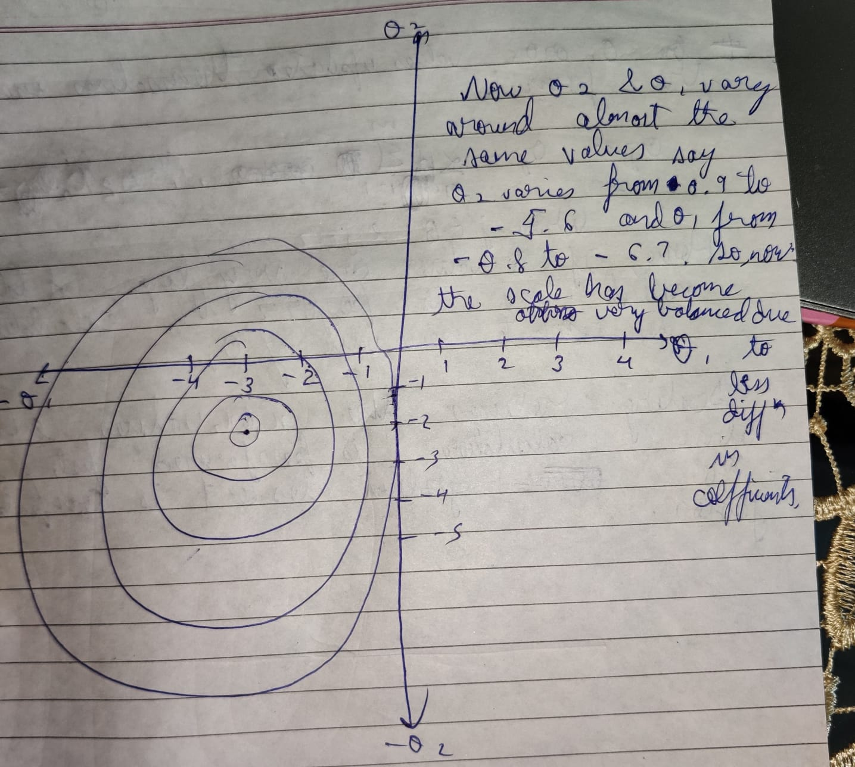

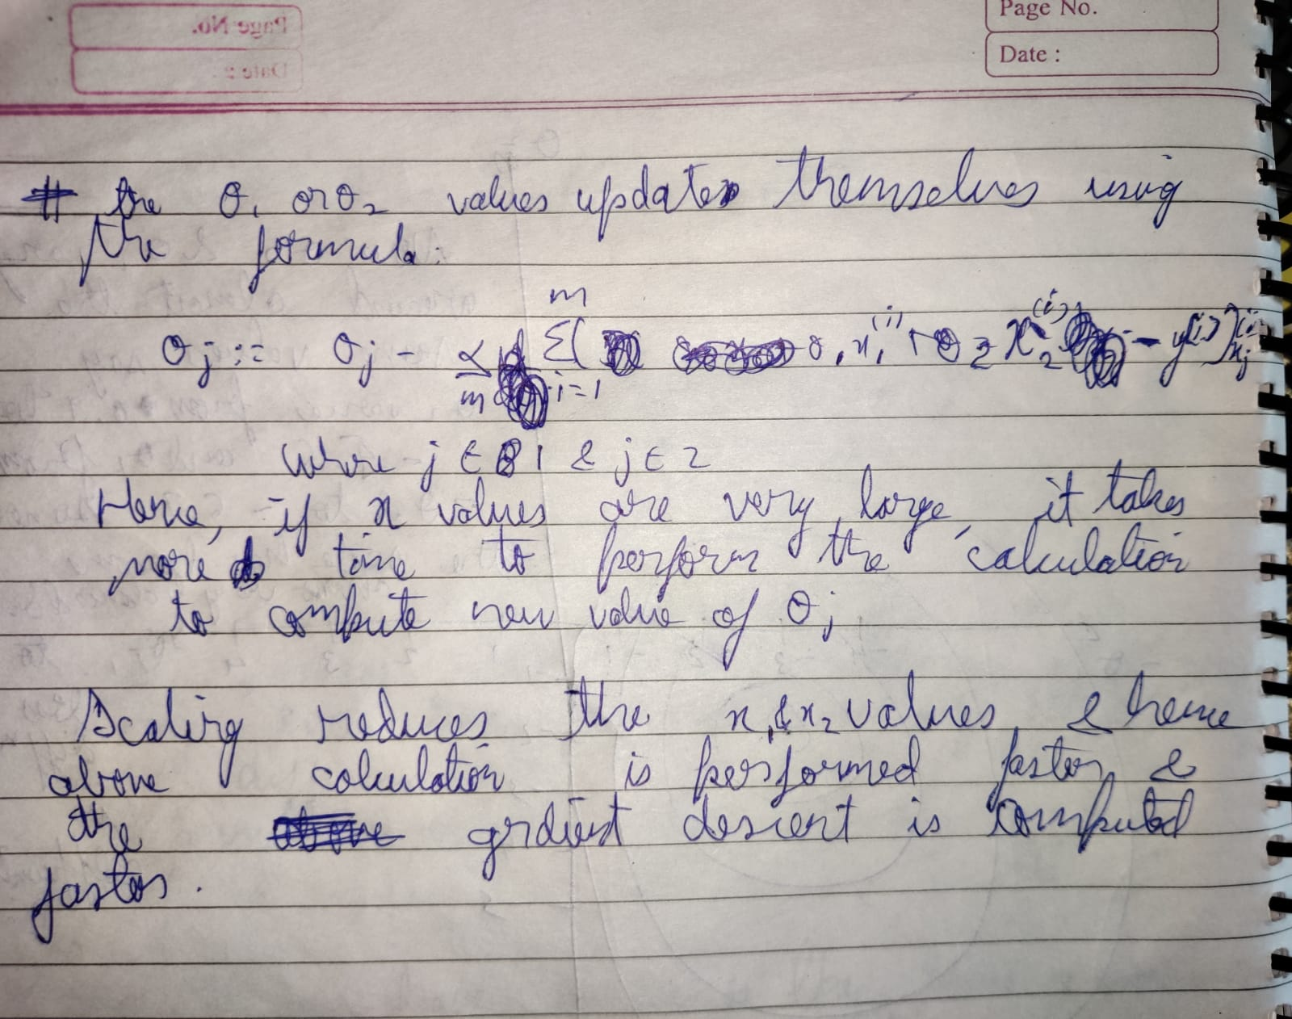

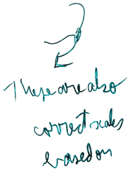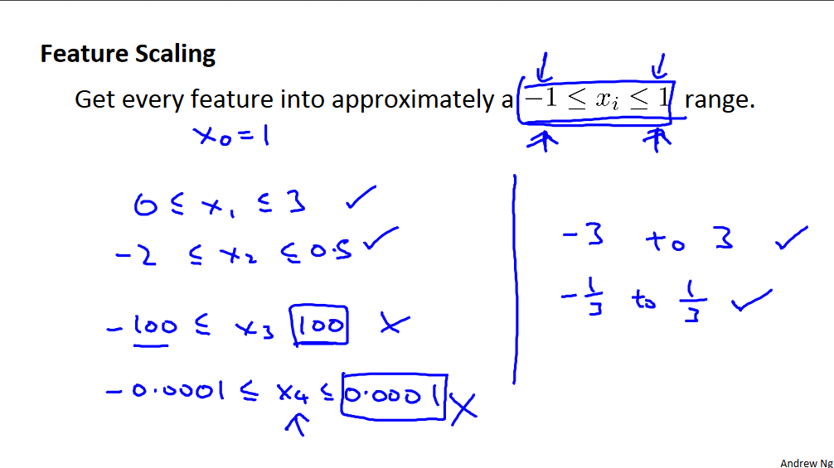



Methods for scaling:

1. Divide the data by upper limit of range – lower limit of range

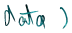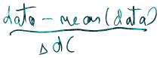2. mean normalisation i.e.

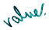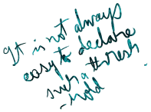**GRADIENT DESCENT AND ALPHA**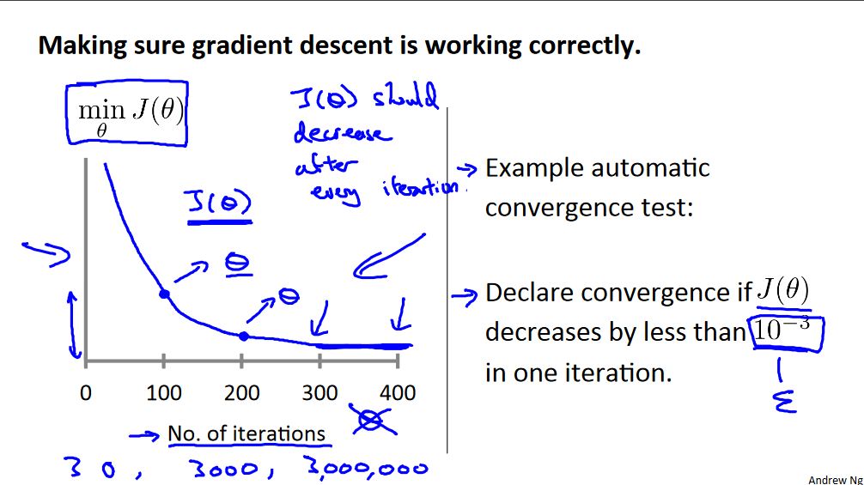



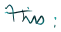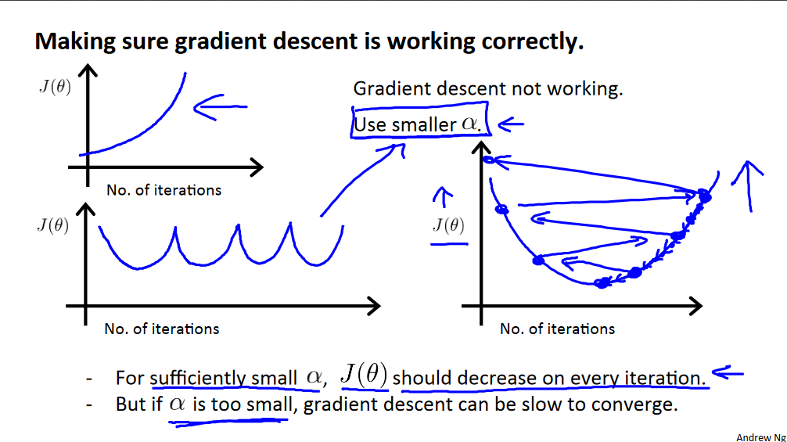

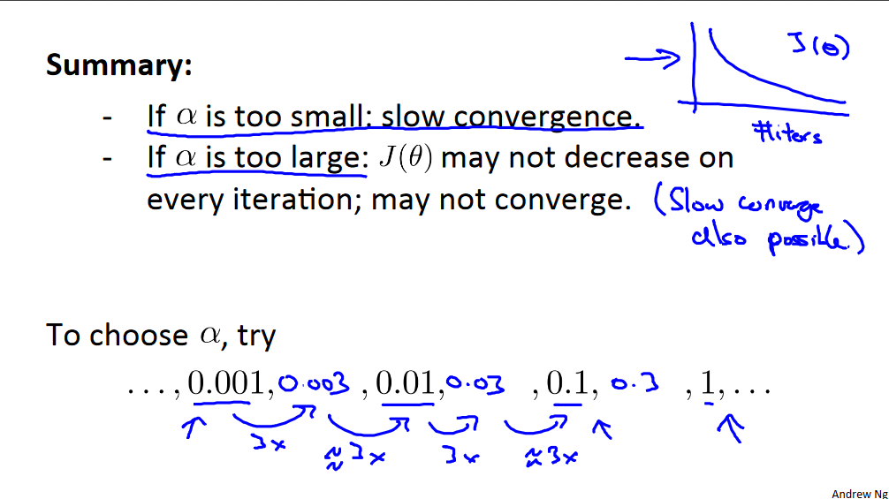

**Above line means we can first assume alpha to be 0.001 and then increase alpha in multiples of 3 and see the no. of iterations.**

**Question:**



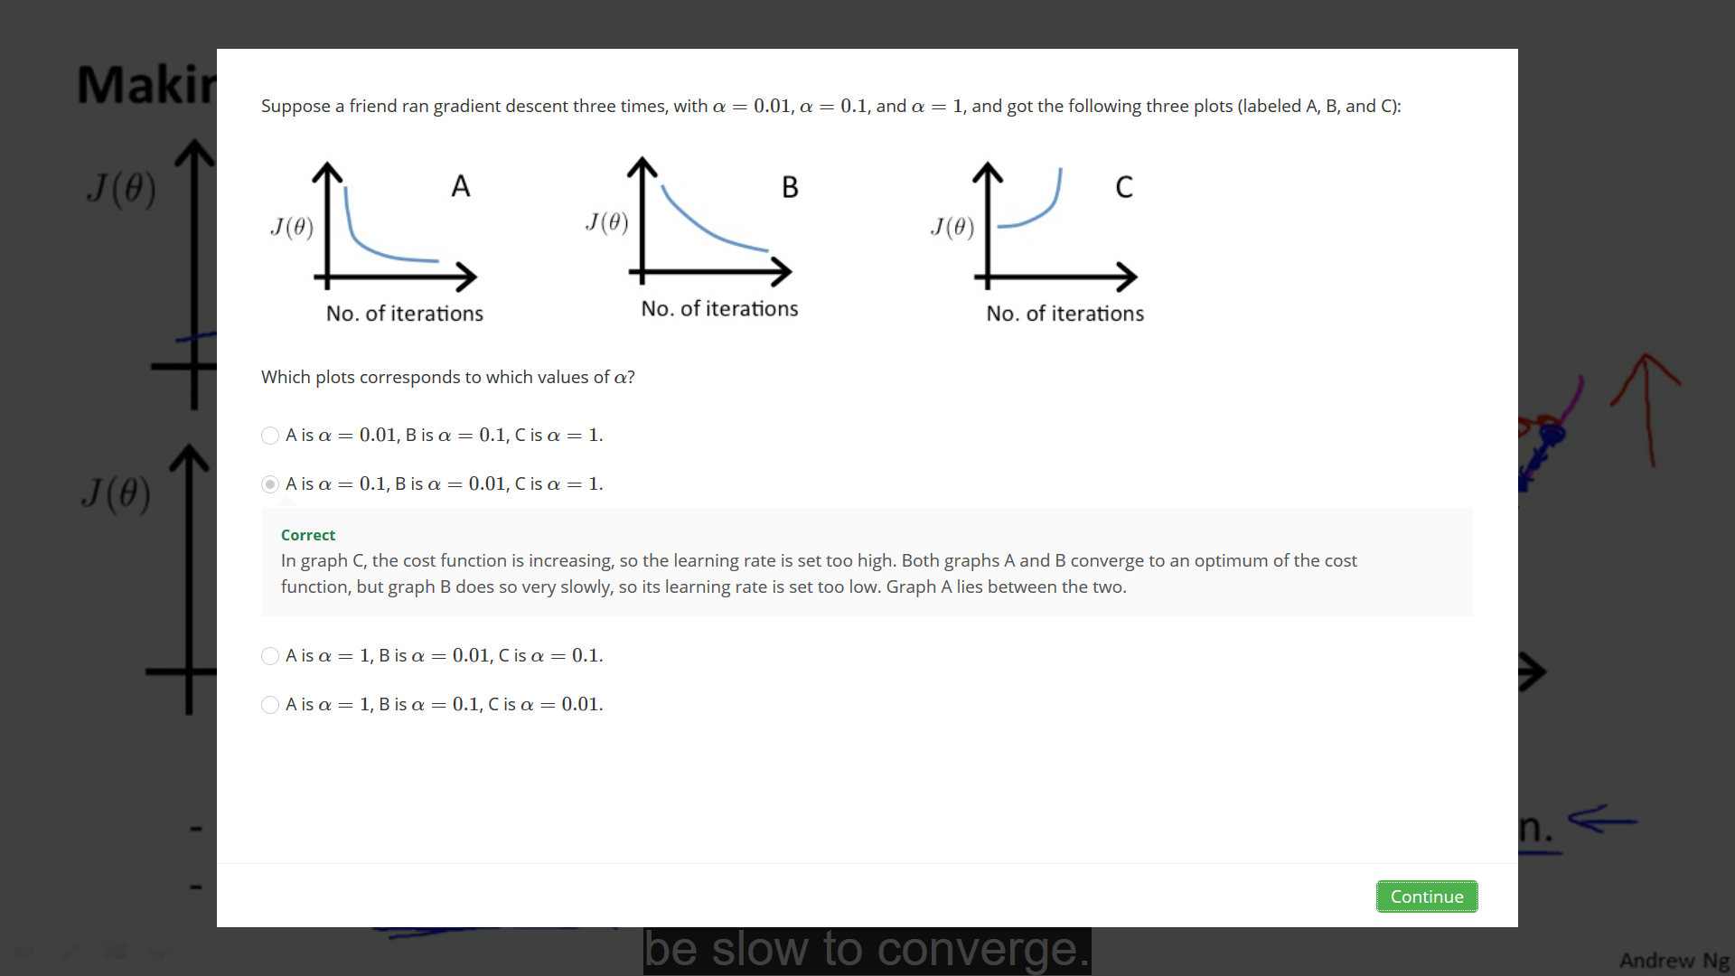

**POLYNOMIAL REGRESSION:**



Sometimes fitting a straight line through the data may not help, we may need to fit a line that corresponds to degree 2 , degree 3 , degree ½ ,etc . equation .

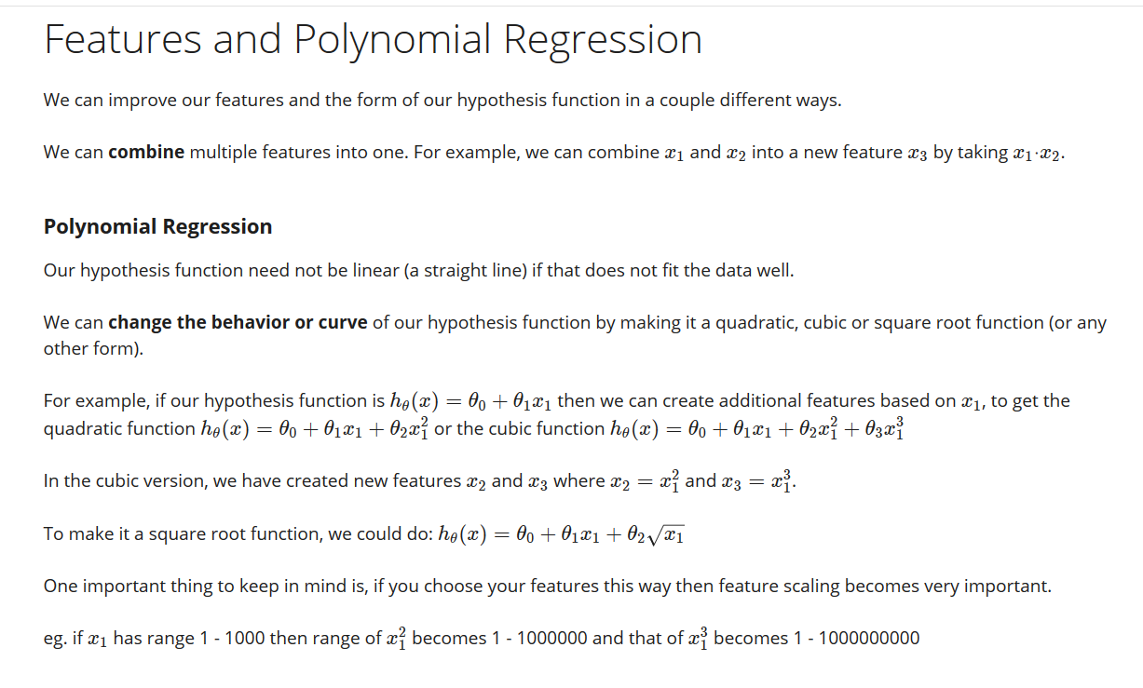

As an example:

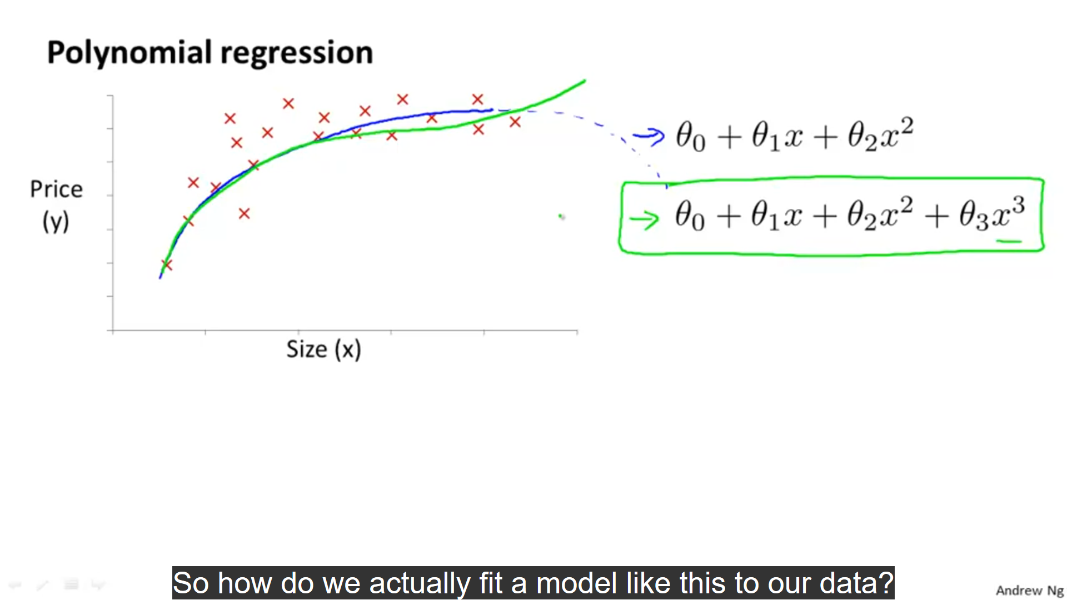



We first fit a degree 2 equation line through the data(represented by blue) , but this curve starts going down from point A and hence it is wrong.

We then fit a degree 3 equation line through the data (represented by green)

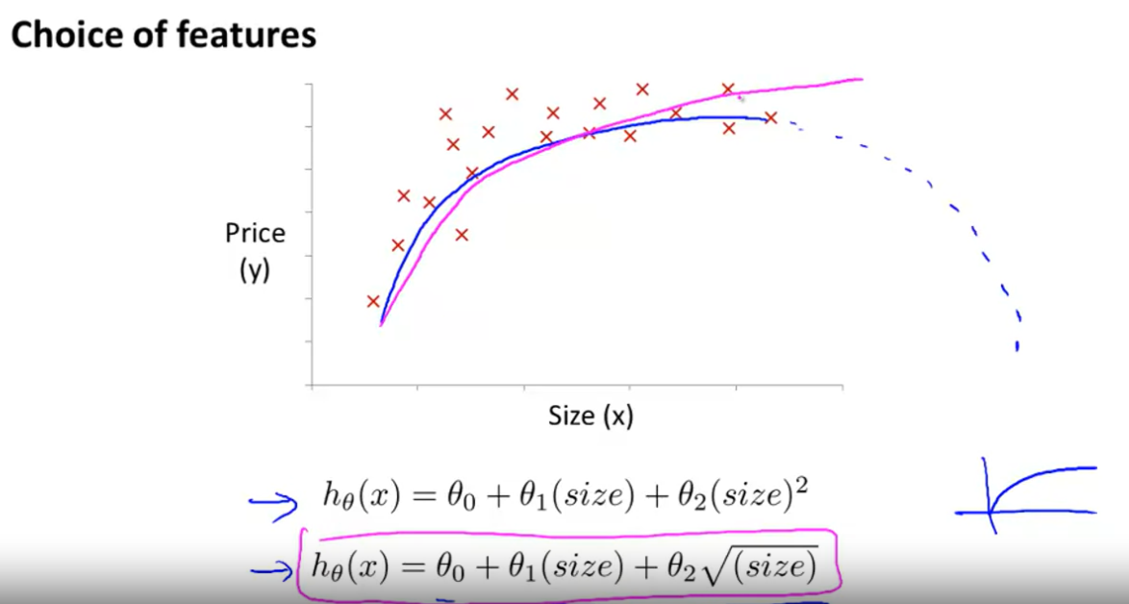

We can also fit a degree ½ equation (represented by pink).

**Normal Equation:**



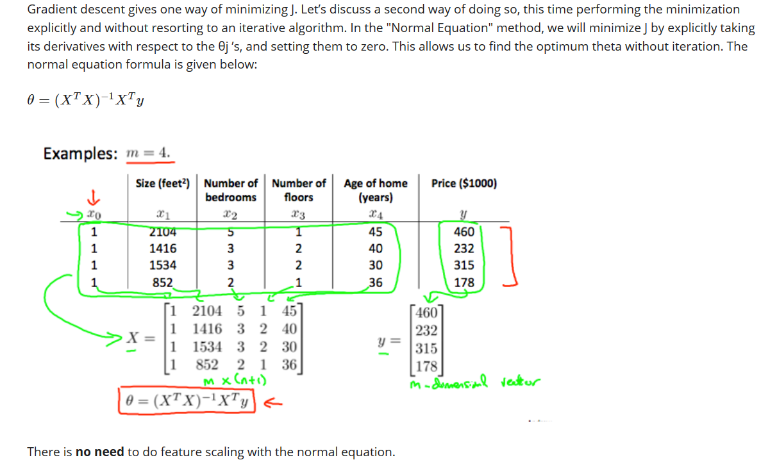

Note: XT is a (n+1) * m matrix , while X is a m * (n+1) matrix. Thus XT*X is a (n+1)*(n+1) matrix. . Thus (XT*X)-1 is also a (n+1)*(n+1) matrix. (XT*X)-1 * XT is a vector of size (n+1)*m . y is a vector of size m or a m*1 matrix and hence ( (XT*X)-1 * XT )* y is a vector of size (n+1)*1, which also happens to be the dimensions of theta. Where

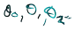From the above formula we obtain values of all respective thetas( ) for which the cost function is minimum.

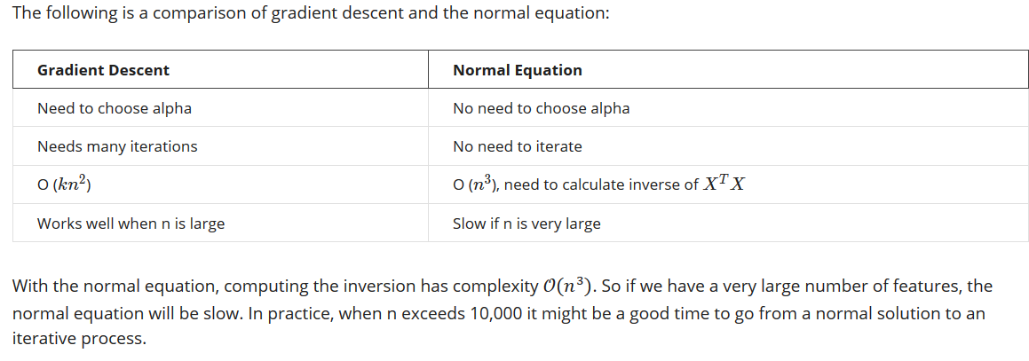

The normal equation gets slow with many samples due to the reason that it takes time for performing computation of matrix related operations for large values of n.

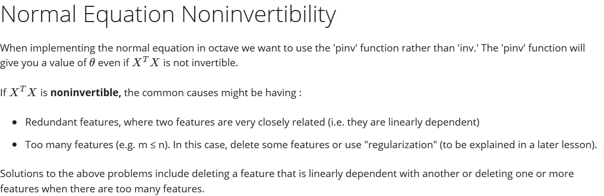

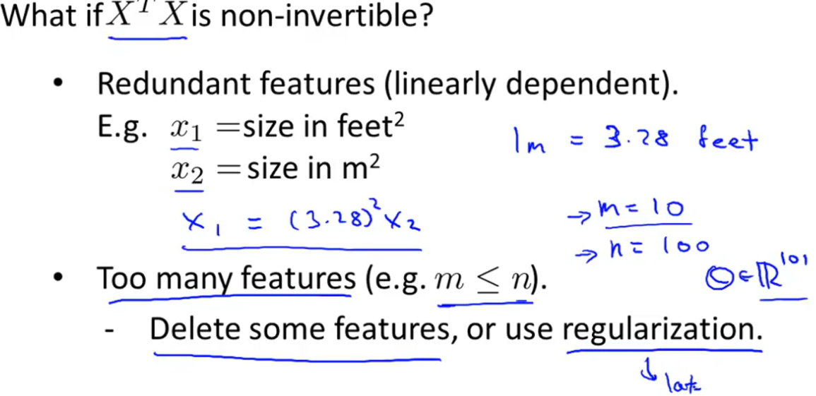

Overfitting:



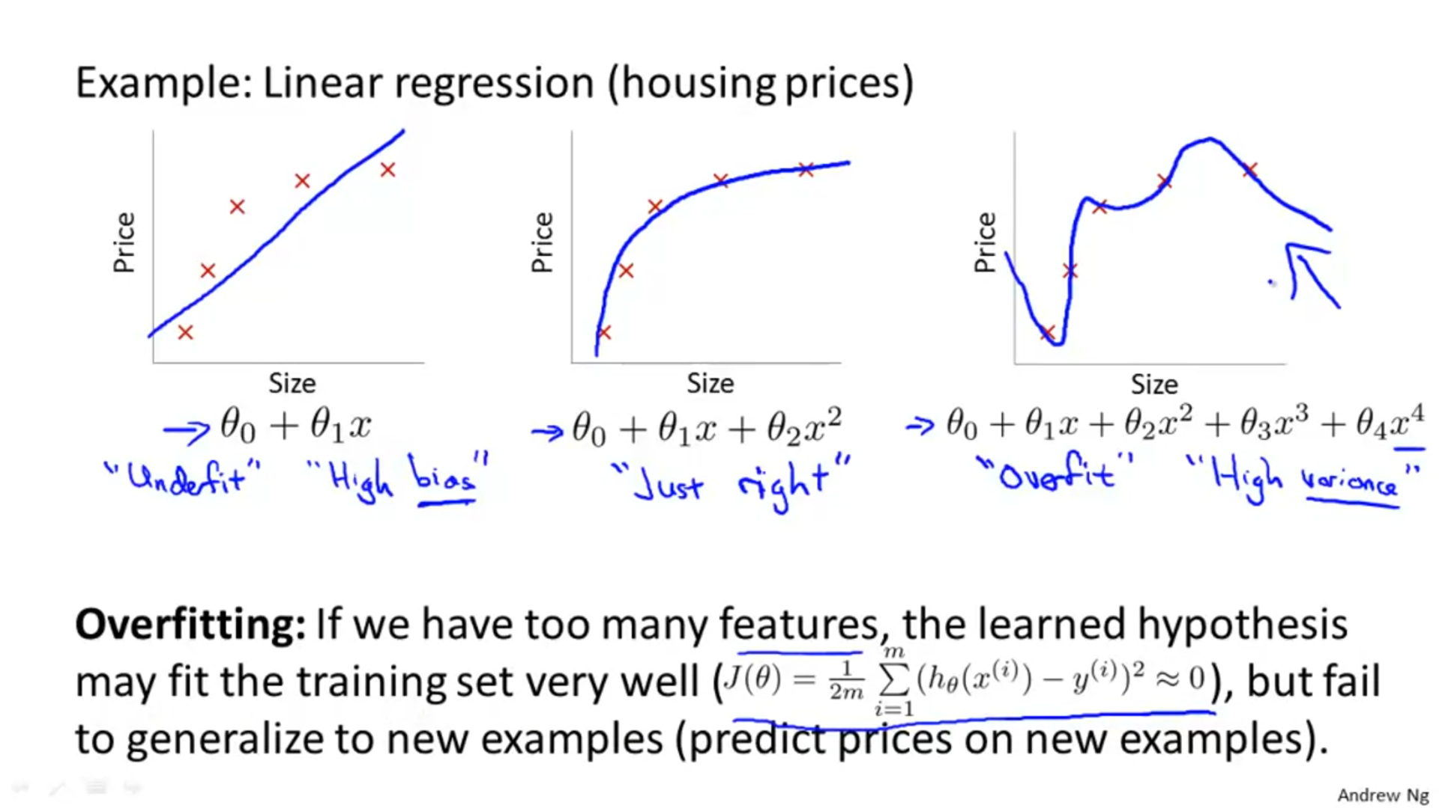

Consider the problem of predicting y from x ∈ R. The leftmost figure below shows the result of fitting a y = θ0+θ1x to a dataset. We see that the data doesn’t really lie on straight line, and so the fit is not very good.

Instead, if we had added an extra feature , and fit y=θ0­+θ1x+θ2x2 ,then we obtain a slightly better fit to the data (See middle figure). Naively, it might seem that the more features we add, the better. However, there is also a danger in adding too many features: The rightmost figure is the result of fitting a 5th order polynomial y=∑5j=0­ θjxj . We see that even though the fitted curve passes through the data perfectly, we would not expect this to be a very good predictor of, say, housing prices (y) for different living areas (x). Without formally defining what these terms mean, we’ll say the figure on the left shows an instance of **underfitting**—in which the data clearly shows structure not captured by the model—and the figure on the right is an example of **overfitting**.



Underfitting, or high bias, is when the form of our hypothesis function h maps poorly to the trend of the data. It is usually caused by a function that is too simple or uses too few features. At the other extreme, overfitting, or high variance, is caused by a hypothesis function that fits the available data but does not generalize well to predict new data. It is usually caused by a complicated function that creates a lot of unnecessary curves and angles unrelated to the data.

Above terminology is applied to both linear and logistic regression

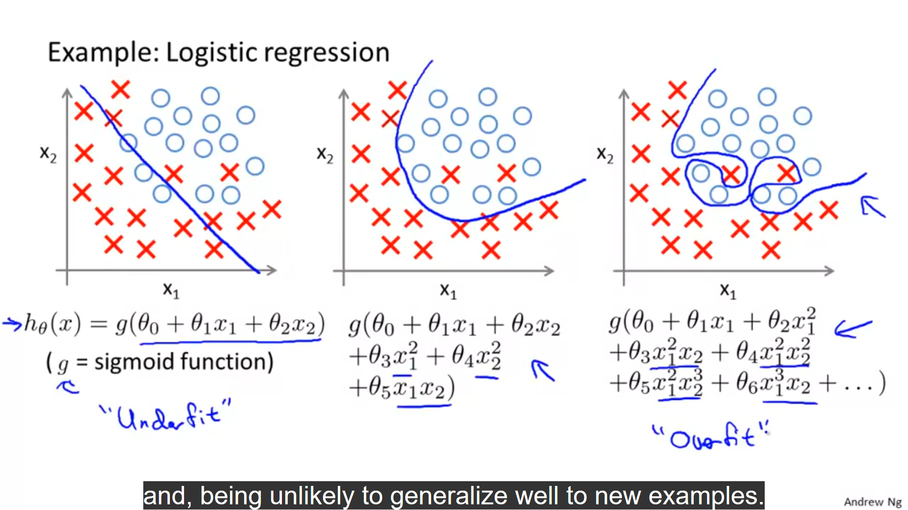

There are two main options to address the issue of overfitting:

1) Reduce the number of features:

* Manually select which features to keep.
* Use a model selection algorithm (studied later in the course).

2) Regularization

* Keep all the features, but reduce the magnitude of parameters θj​.
* Regularization works well when we have a lot of slightly useful features.

Regularisation:

When our model is underfitting the data i.e. not able to predict the trend there in the training data properly, we may think of adding more parameters in it to increase the accuracy of prediction. Although this may seem to solve the problem , we have to realise that this can lead to overfitting that is , our model can adjusts itself according to the loopholes there in the training data and hence predicts the training data very accurately , but can’t do the same on new data. In the example given as we introduce x3 and x4 term in our equation y= theta0 + theta11 *x +theta2x2 , though the predictions become more accurate , the problem of overfitting also arises.

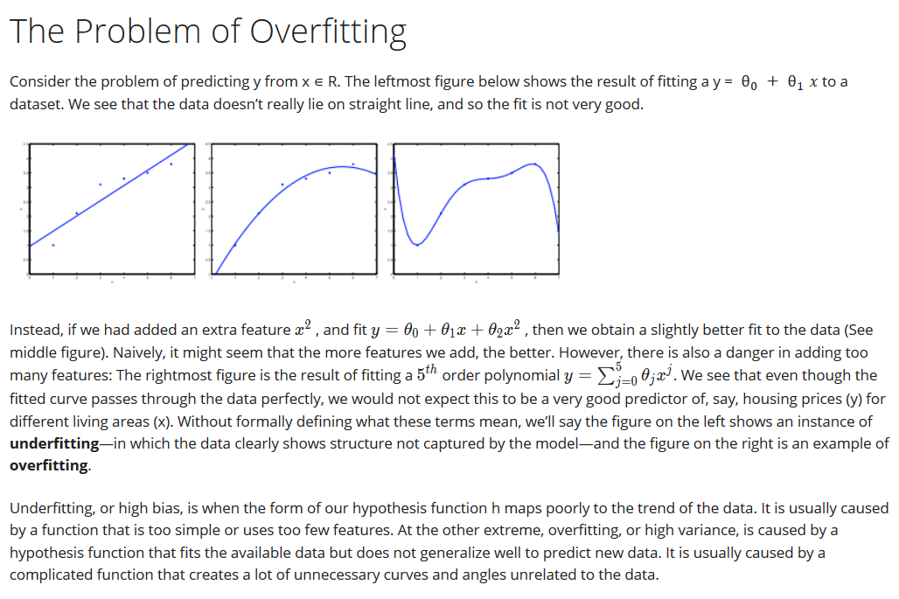

So what we do is that we introduce a regularisation term in our cost function equation. What this term does is that ‘keeps a track’ on the new features we add in the equation for better fitting of the model. The way it keeps a track is by increasing the value of the cost function if the theta values corresponding to the features/regressors is large. As we want our cost function to be less, the values of theta corresponding to regressors are kept balanced. This also prevents assignment of unnecessary weight to any of the regressors.

##Some screenshots from an article on regularisation:

Find the article here: https://towardsdatascience.com/regularization-in-machine-learning-76441ddcf99a

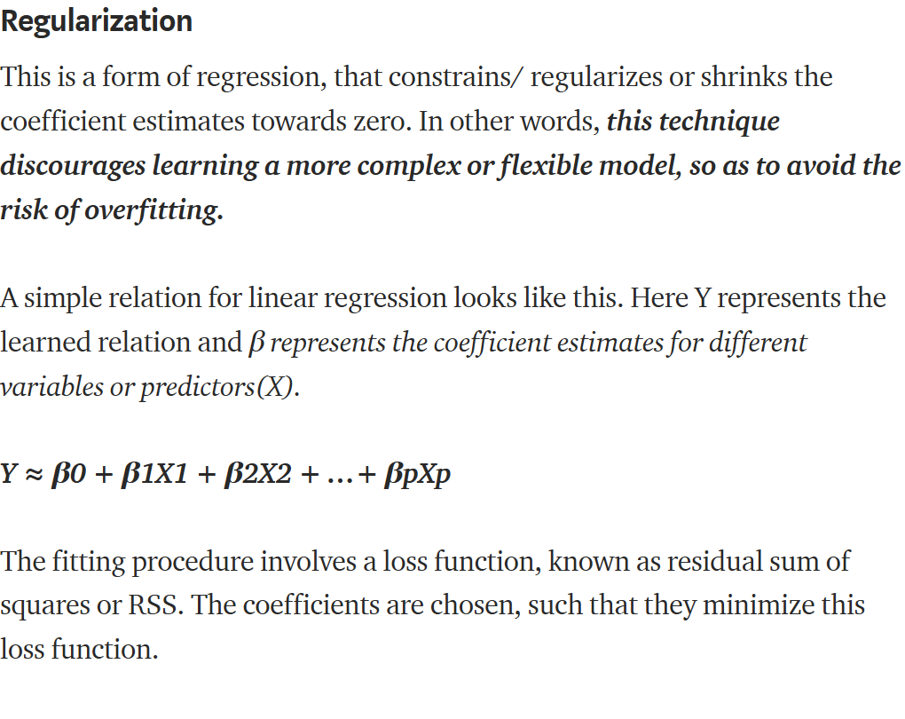

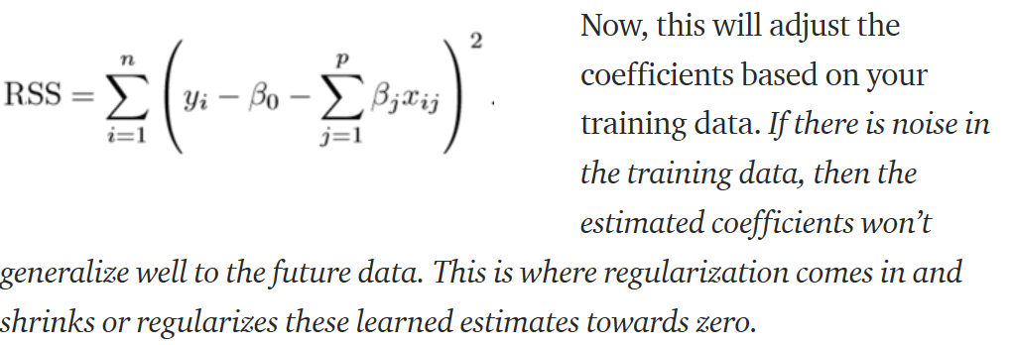

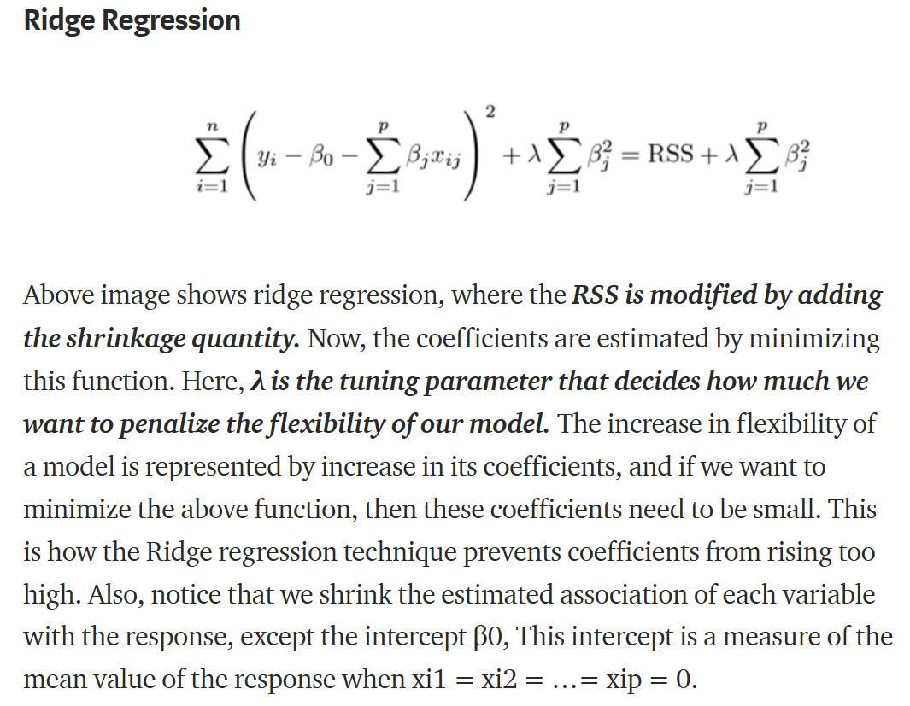

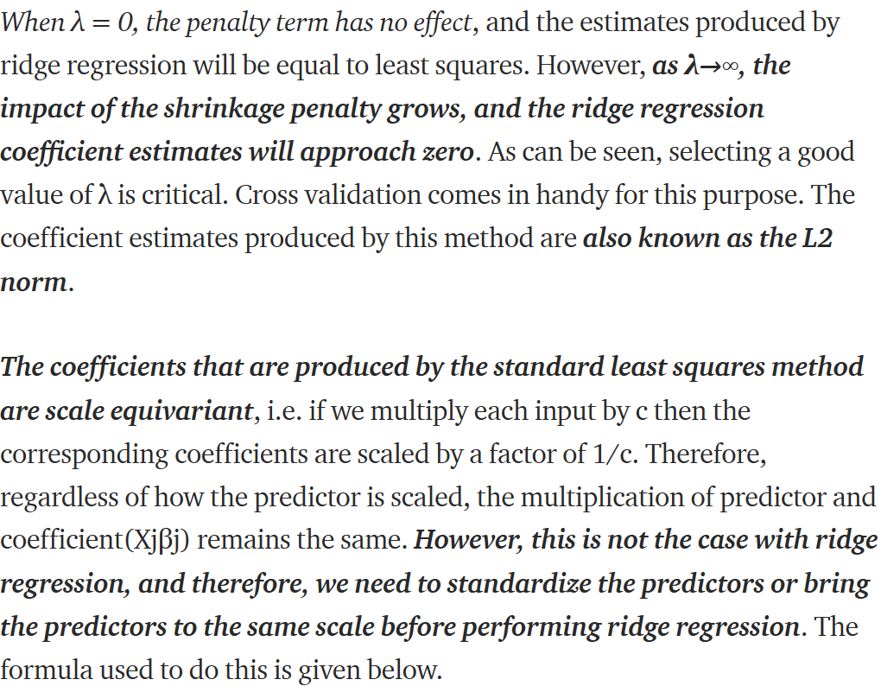

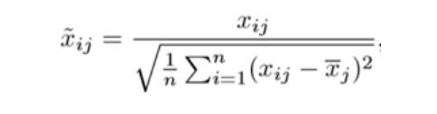

**NOTES FROM COURSERA:**

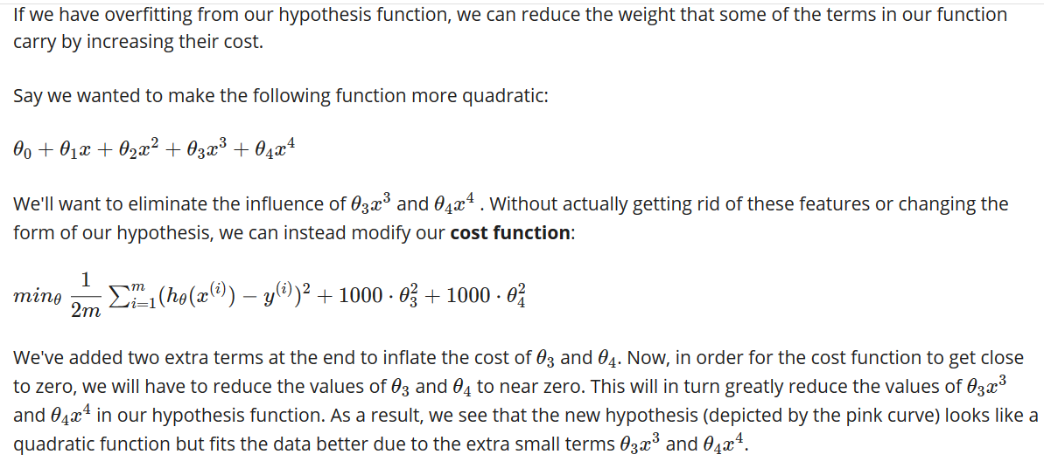

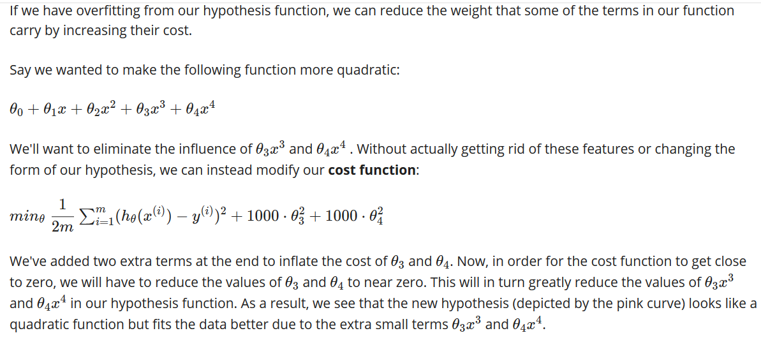

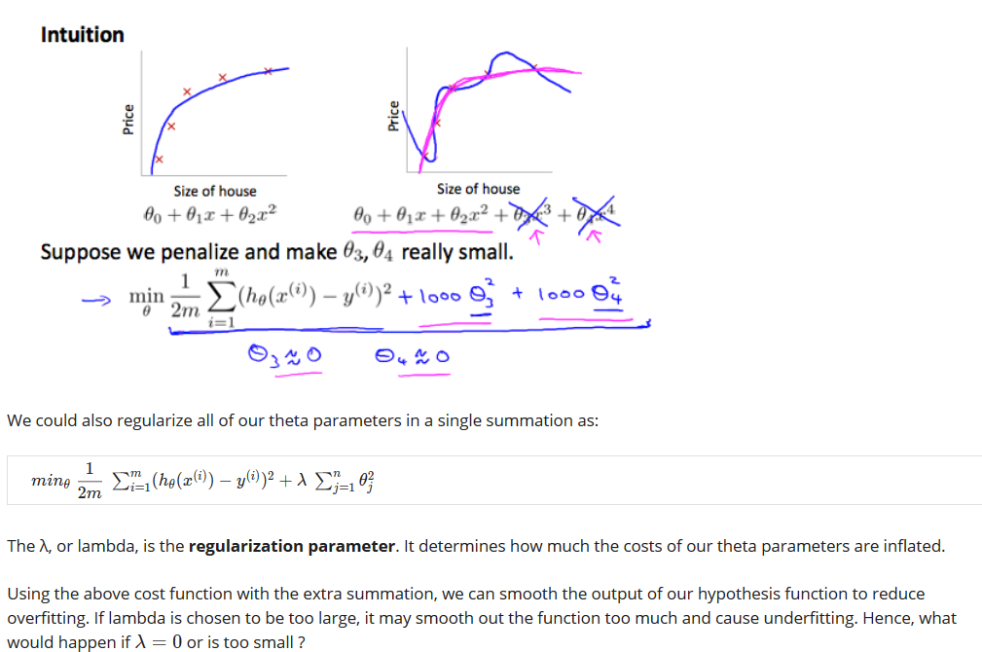

When lambda is too large we obtain a trend line parallel to the x axis. This is because to minimize the cost function theta1 ,theta2….thetan will assume values that tend to 0 and hence our model will become y= theta0 + 0 , which explains the horizontal line parallel to x axis.

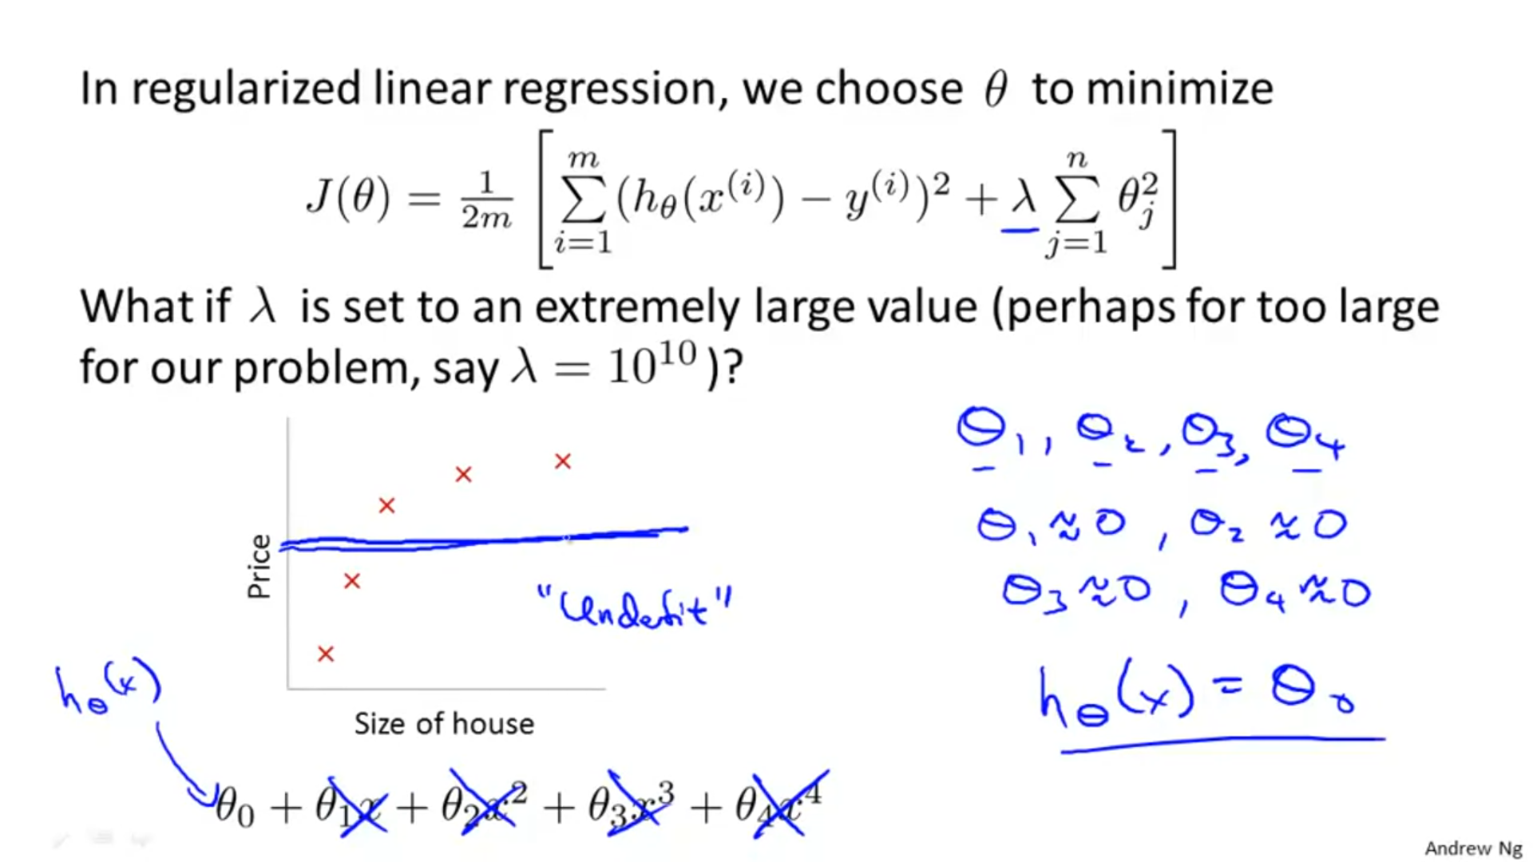

**Regularisation and linear regression:**

How the formula changes on adding the regularisation term:

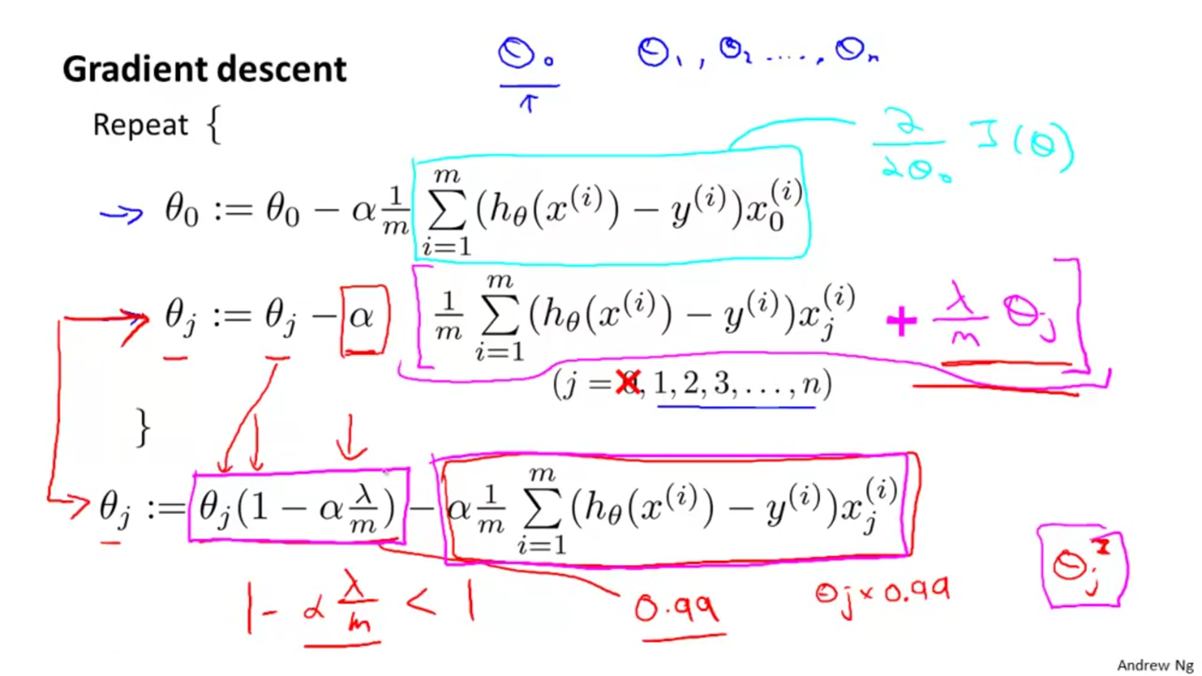

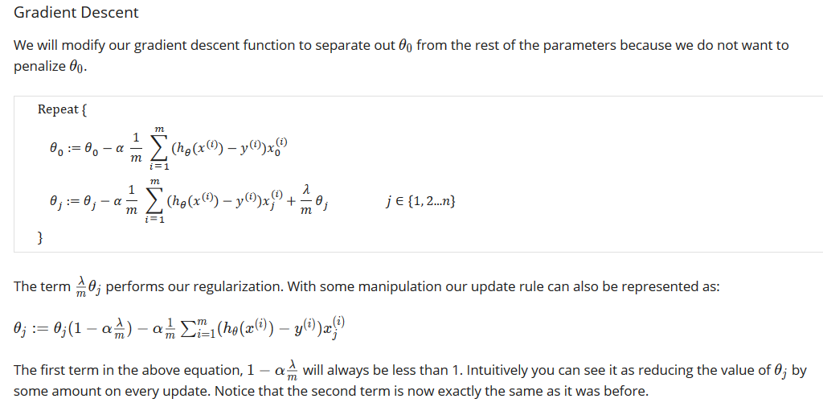

How the normal equation formula changes: 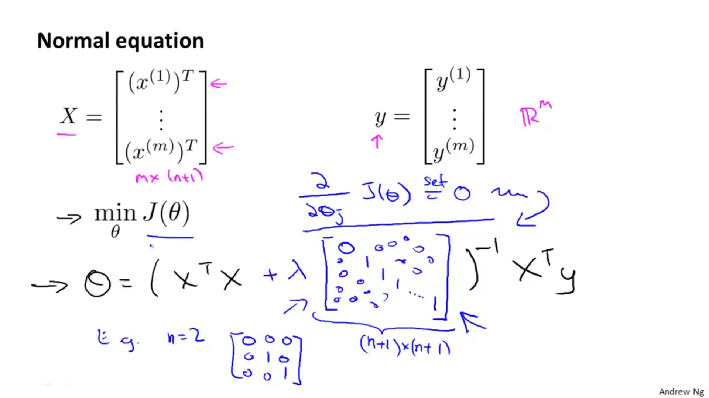

Note: If m<=n , then the matrix (XTX) becomes non – invertable. The regularisation term lamba*the matrix shown in the figure below make this (XTX) invertable even when m<=n. So adding this regularisation has one more advantage other than regularisation itself.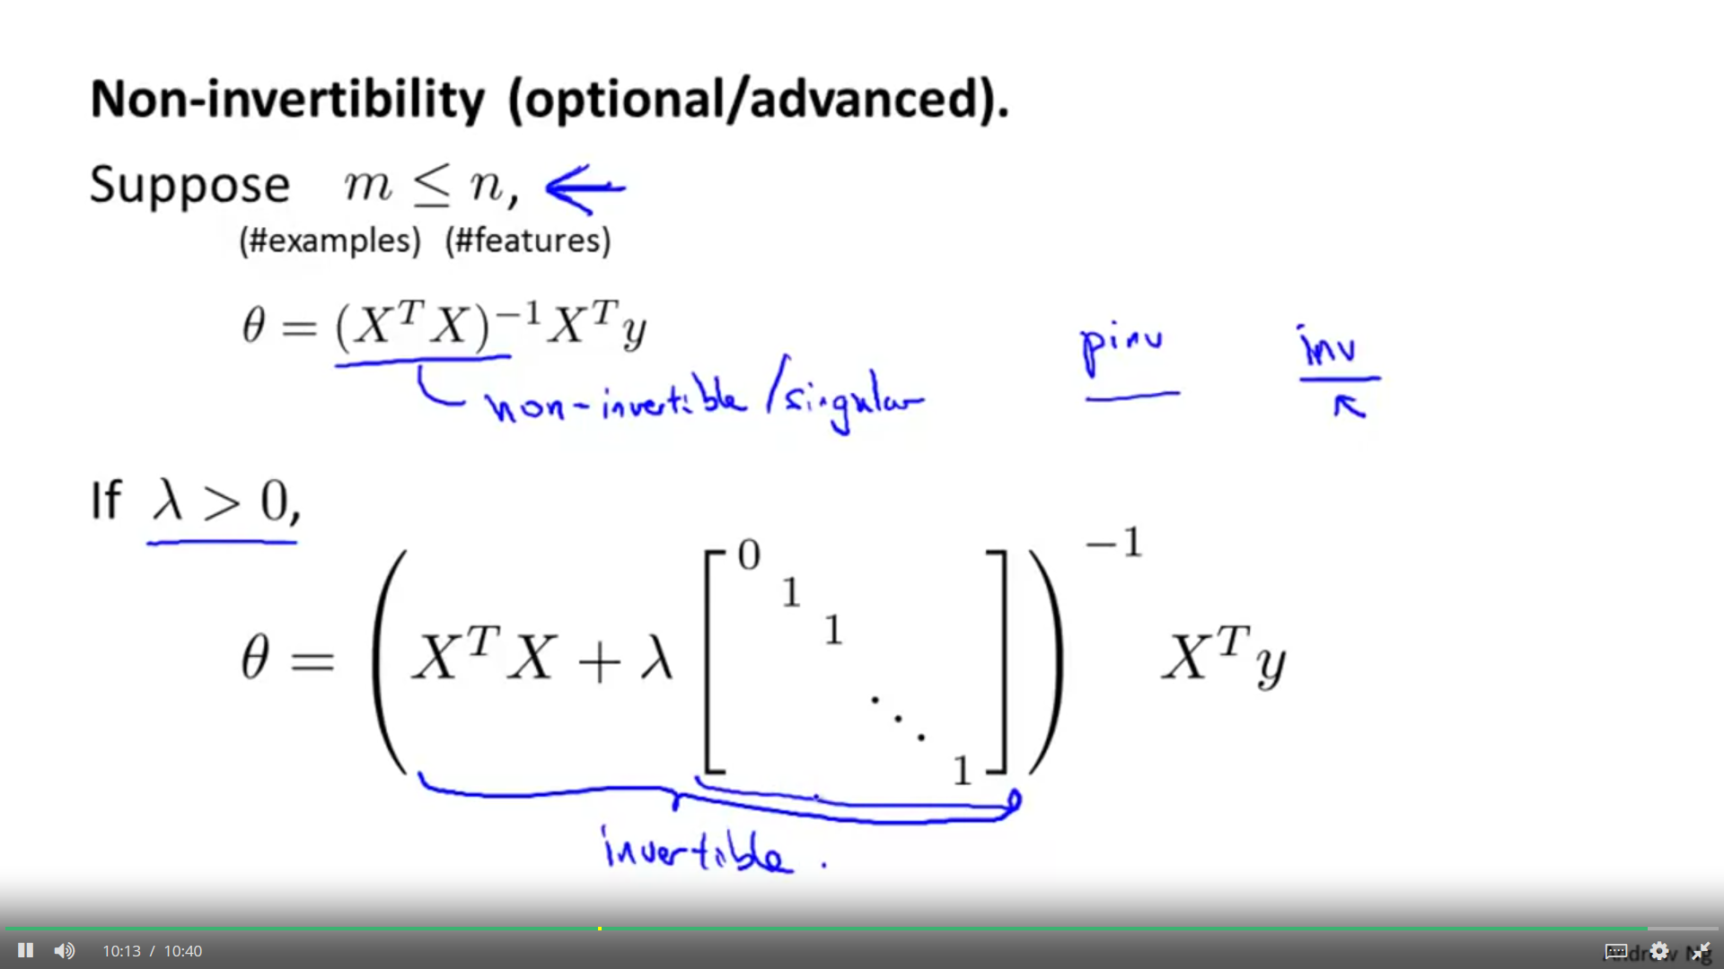

**Coursera notes:**

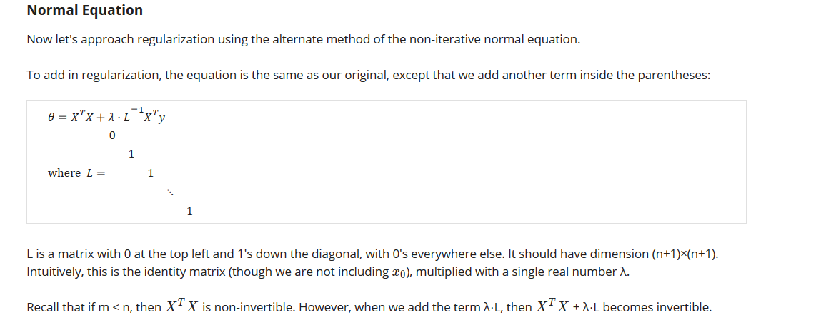

Question:

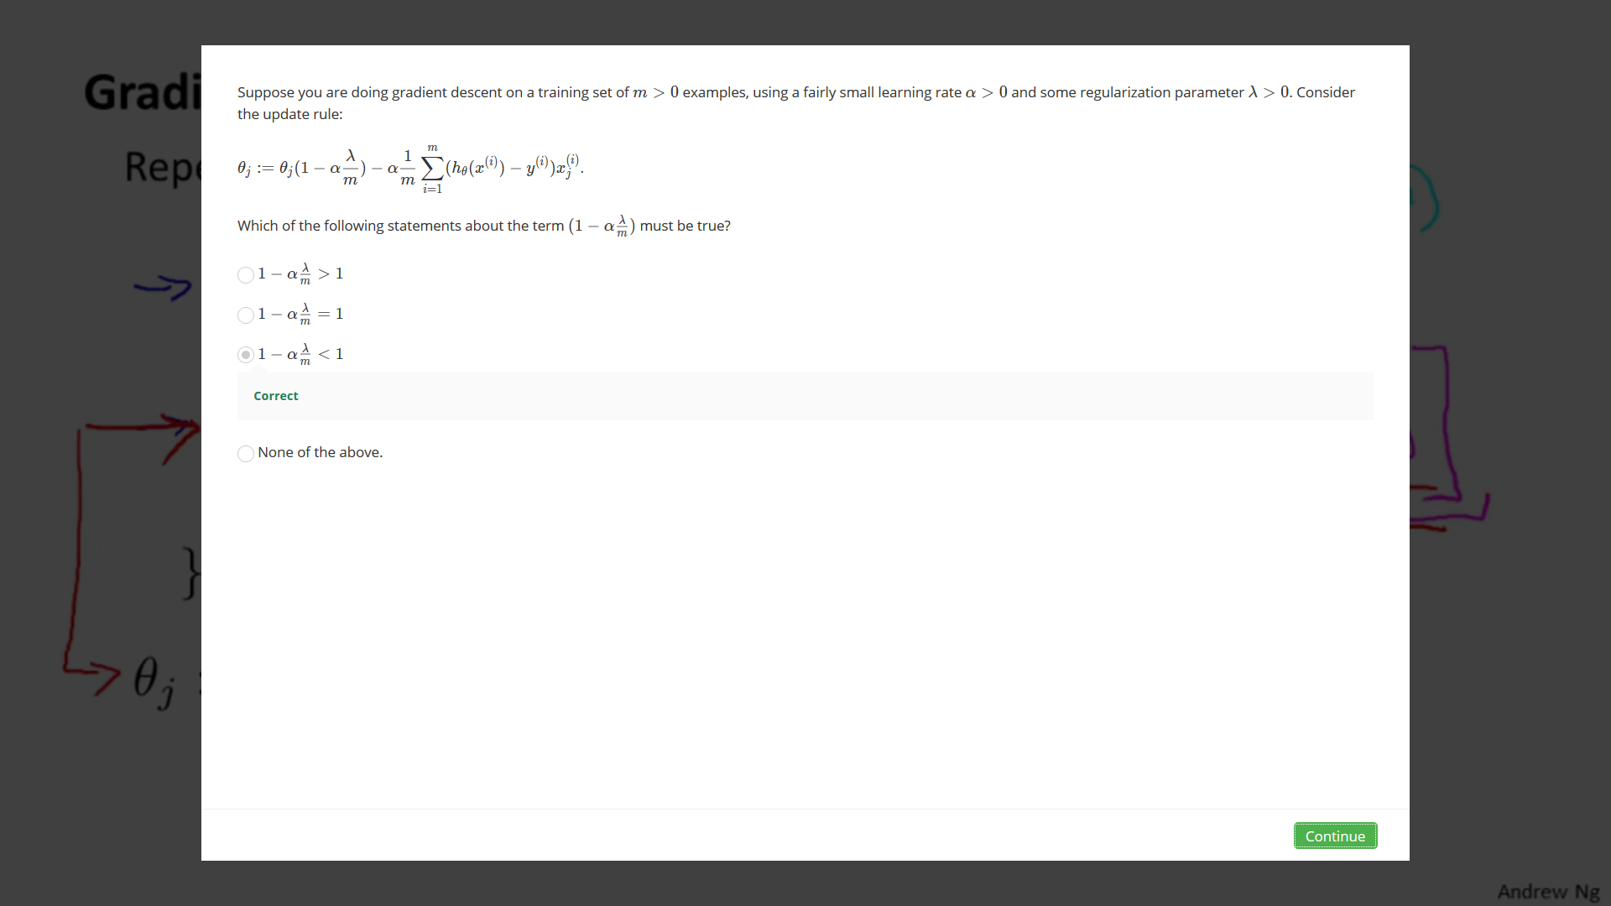

**Regularisation and logistic regression:**

Even when we fit high order terms like x12*x23 in our equation , we don’t overfit the model since due to regularisation , the coefficients like theta5 corresponding to these terms decrease their magnitude and hence adjust their effect. The blue line shows an instance of overfitting and the line in pink is the regularized equation.

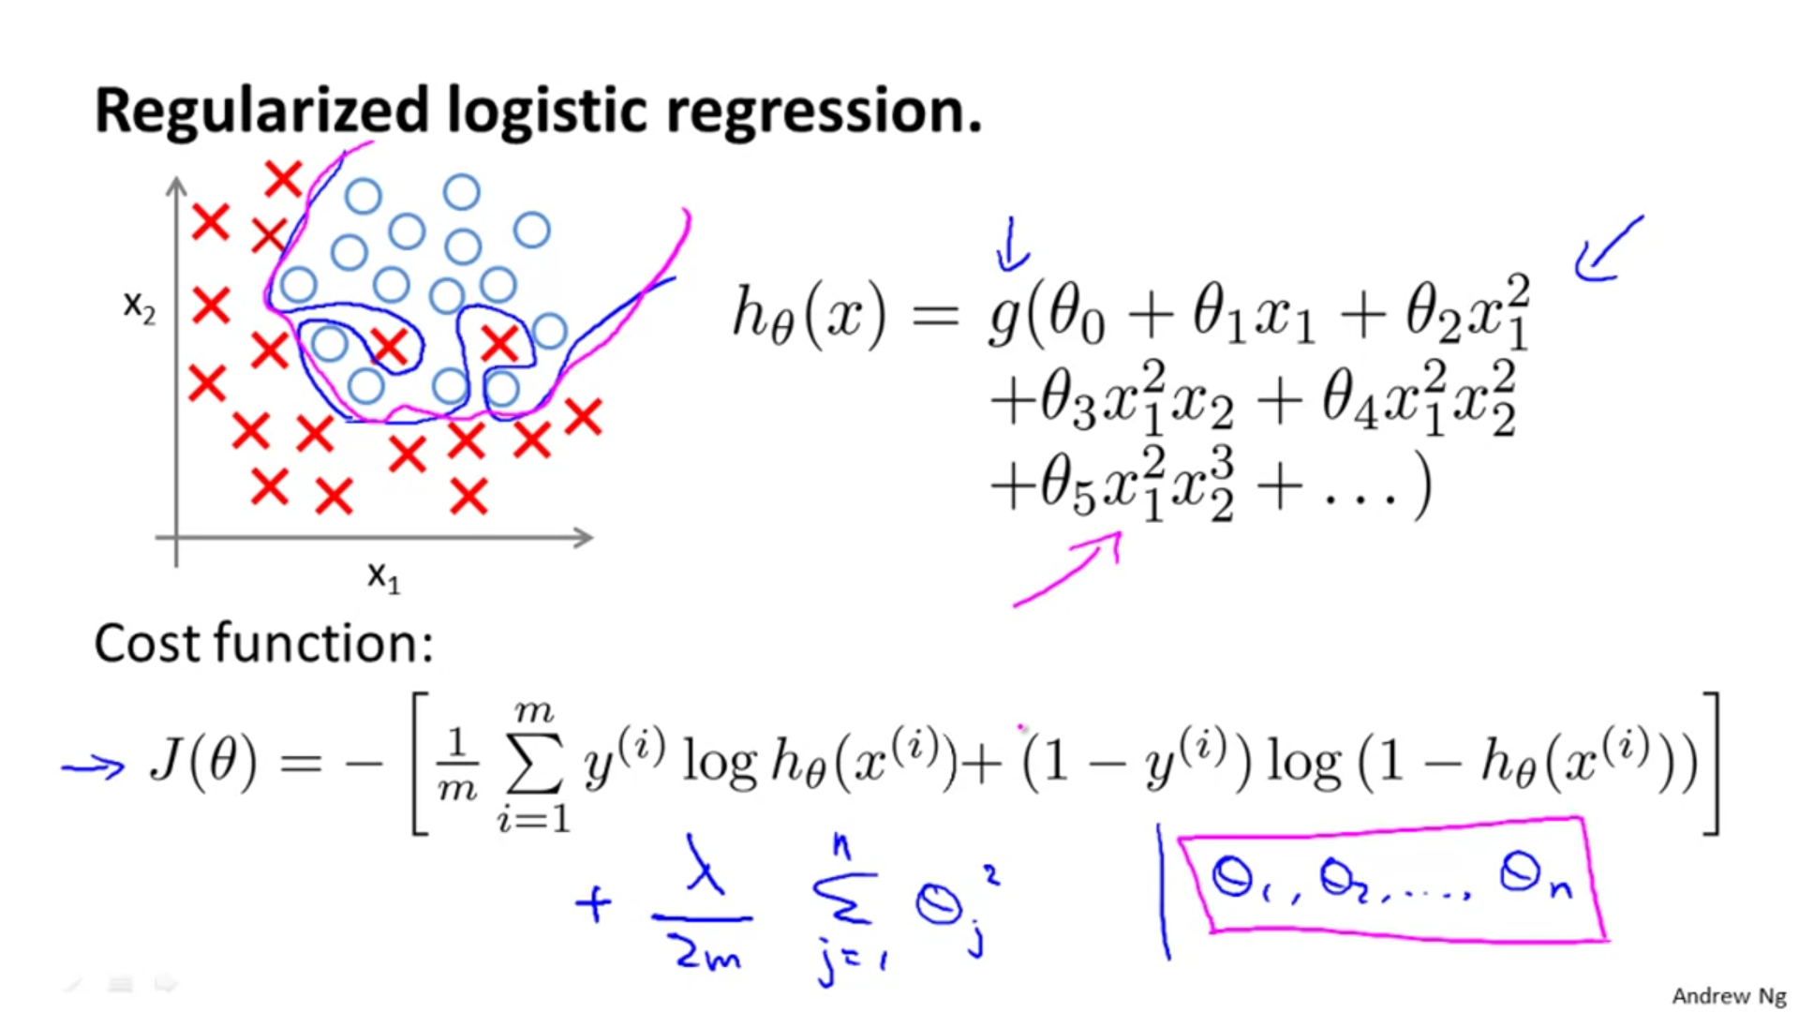

Changes in the formula :  
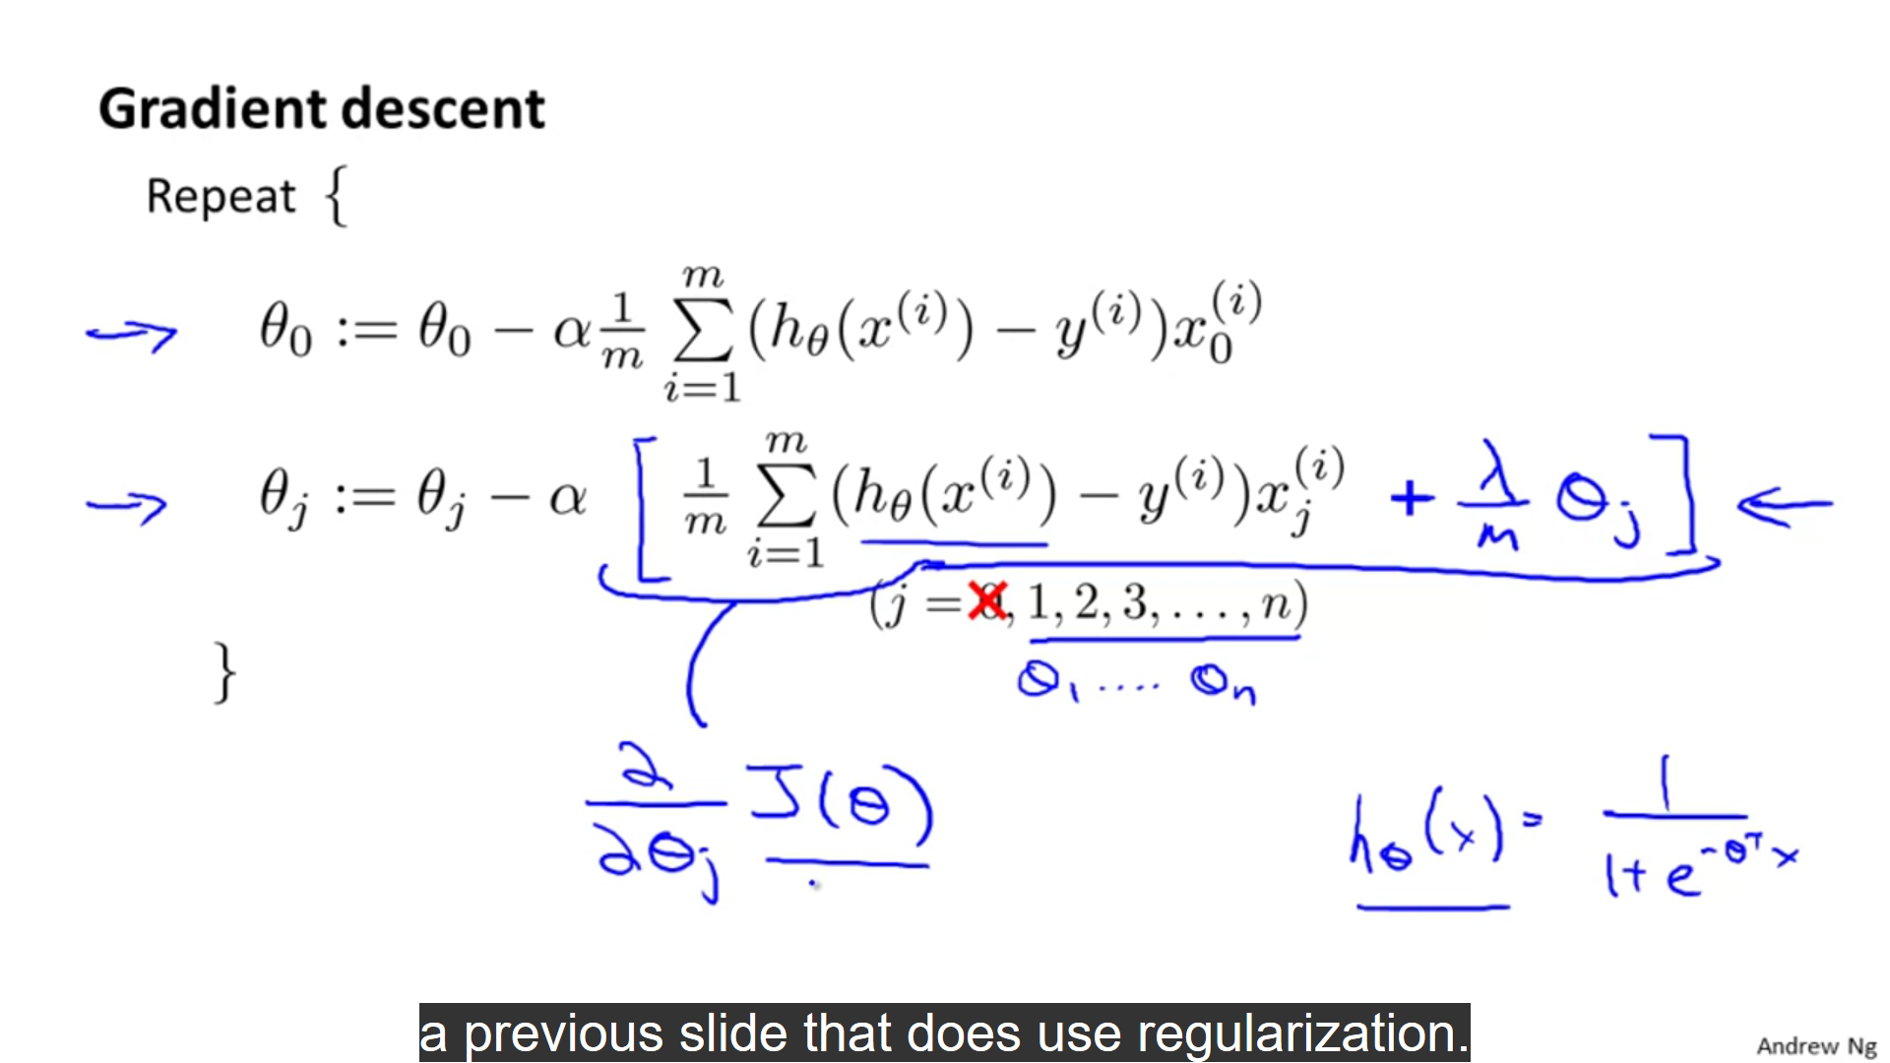

The fminunc function and regularisation in octave:

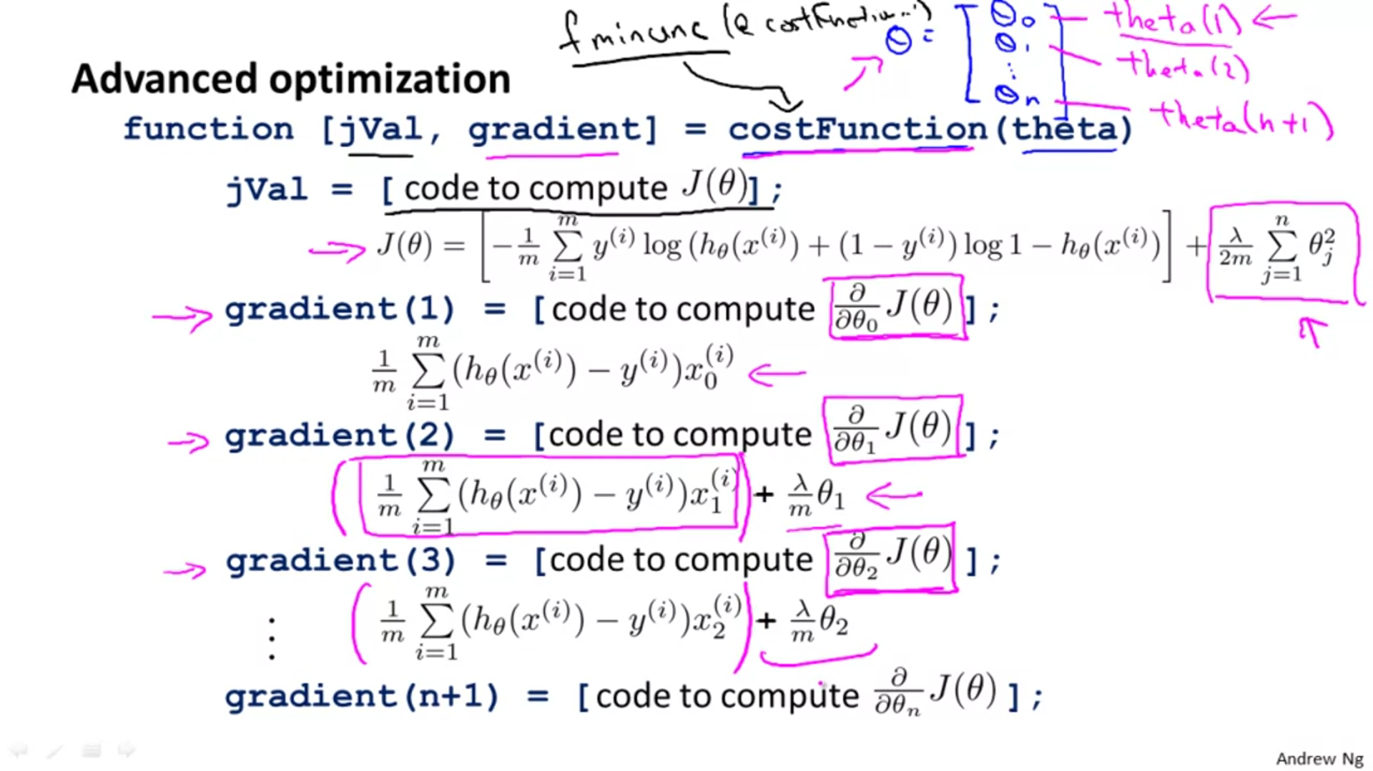

Question:  
